**THE REPUBLIC OF TURKEY**

**BAHÇEŞEHIR UNIVERSITY**

**GRADUATE SCHOOL OF NATURAL AND APPLIED SCIENCE**

**ASSOCIATION RULES MINING AN APPLICATION ON A CAFE SALES DATA AT AIRPORT**

**BIG DATA ANALYTICS AND MANAGEMENT MASTER'S**

**(ENGLISH, PROJECT)**

**MEHMET ALİ VAROL**

**İSTANBUL, 2018**

**THE REPUBLIC OF TURKEY**

**BAHÇEŞEHIR UNIVERSITY**

**GRADUATE SCHOOL OF NATURAL AND APPLIED SCIENCE**

**ASSOCIATION RULES MINING AN APPLICATION ON A CAFE SALES DATA AT AIRPORT**

**BIG DATA ANALYTICS AND MANAGEMENT MASTER'S**

**(ENGLISH, PROJECT)**

**MEHMET ALİ VAROL**

**Supervisor: Assist. Prof. Serkan AYVAZ**

**İSTANBUL, 2018**

ACKNOWLEDGMENT

I would like to thank my advisor Assist. Prof. Serkan AYVAZ who supported me during my master program and a final project.

And thanks to Mr. Mesut Zerman to all of his support for my project work.

Finally, I would like to thank my family who has always been with me throughout my life.

İstanbul, 2018 Mehmet Ali VAROL

ABSTRACT

Every field living their own data revolution. In every sector, you can think of developments related to data taking place. It’s a parallel process going together with unbelievable speed development of technology. With tools which have more abilities, data has become more important than ever in history. This situation led to the fact that the data was considered a valuable asset to be invested.

Marketing is one of the first sectors to makes the reaction to this type of evolution. Evolution brings a lot of opportunities together like increase the profit, productivity, better customer experiences etc. Over time, the data saved by firms gained more volume and same firms have capable tools able to handle this. The discovery of knowledge from data seems to be meaningless has gained importance. E-commerce is one of the pioneering sectors to use data mining technics in their data. Amazon is a good example of this. Amazon used their historical sales data to recommend new products to their customers. The general purpose of the basket analysis is to gather information for the department, corridor or menu arrangement, which is intended for the needs, pleasure or needs of the customer who shops in any retail store (virtual or real). In the space designed according to this information, the customer will be able to move away from unnecessary image pollution and see reduced products for their demand.

This study involves an application of famous association rules algorithms from data mining technics to three airport café dataset. In summary, the rules of association aim to reveal the relationships between the products that the customers receive. Thus, it is possible to analyze the cross-selling habits of products through relationship relations. With the information obtained from the analysis with using association rules algorithms aimed to review the selling strategies, to do more attractive recommendations to customers, to redesign products settlement in the cafes and finally to contribute redesign of the menu.

**Keywords:** market basket analysis, data-driven marketing, association rules mining, apriori algorithm

CONTEXT

ACKNOWLEDGMENT II

ABSTRACT III

CONTEXT IV

ABBREVIATIONS V

TABLES VI

FIGURES VII

SYMBOLS VIII

1. INTRODUCTION 1

2. LITERATURE REVIEW 3

2.1. Data Mining 3

2.2. Association Rules Mining 3

2.3. Model of Association Rules 4

2.4. Apriori Algorithm 5

3. FEATURE SELECTION AND DATA EXPLORATION 8

3.1. Pre-processing of Dataset 8

3.1.1. General Look at Data 8

3.1.2. Data Cleaning Process 9

3.1.3. Creating New Attributes 10

3.2. Data Exploration 10

3.2.1. Terminal 10

3.2.2. Months 11

3.2.3. Day 12

3.2.4. Sales Categories 14

3.2.5. Sales Products 15

4. METHODS 17

4.1. Methodology 17

4.1.1. CRISP-DM 17

5. DATA ANALYSIS AND RESULTS 18

5.1. Apriori Algorithm on Products 18

5.2. Apriori Algorithm on Categories 26

5.3. Similarity on Categories 32

5.4. Analysis of the Excluded Data 34

6. DISCUSSION 36

7. CONCLUSION 38

8. References 39

ABBREVIATIONS

SQL Structured Query Language

TID Transactions Identifier Number

LHS Left Hand Side

RHS Right Han Side

KDD Knowledge Discovery from Data

TABLES

Table 2.1 An example of sales dataset transactions [4] 6

Table 2.2 Apriori algorithm [5] 7

Table 3.1 Attributes of raw dataset 8

Table 3.2 Terminal 11

Table 3.3 Months 12

Table 3.4 Day 13

Table 3.5 Top ten sales category 14

Table 3.6 Top ten sales items 15

Table 5.1 Sales categories for sold alone 34

Table 5.2 Rules of sales categories with the highest confidence 35

FIGURES

Figure 2.1 Algorithm Apriori [5] 6

Figure 3.1 Terminal amount & qty 11

Figure 3.2 Month vs amount&qty facet terminal 12

Figure 3.3 Day vs Amount&qty facet terminal 13

Figure 3.4 Terminal vs amount and quantity facet category 15

Figure 3.5 Terminal vs amount facet products 16

Figure 4.1 CRISP-DM Process Diagram [7] 17

Figure 5.1 Product and categories 18

Figure 5.2 Transactions of products 19

Figure 5.3 Top ten products 19

Figure 5.4 Association rules of product 22

Figure 5.5 Rules of product scatter plot 23

Figure 5.6 Rules of ÇAY KÜÇÜK 24

Figure 5.7 Rules of ÇAY KÜÇÜK list 24

Figure 5.8 Rules of “SANDVIC_PEYNIRLI_MINI_ESMER_EKMEKTE” 25

Figure 5.9 Transaction of categories 26

Figure 5.10 Top ten sales categories 26

Figure 5.11 Association rules of categories 27

Figure 5.12 Rules of categories 28

Figure 5.13 Rules of categories scatter plot 29

Figure 5.14 Çay-Sandviç Rules 29

Figure 5.15 Sandviçler-Çay Rules 30

Figure 5.16 Kahvalti Büfe Rules 31

Figure 5.17 Kahve Unlu Rules 32

Figure 5.18 Dendrogram for categories 33

Figure 5.19 Rules for sold alone categories 35

SYMBOLS

|  |  |
| --- | --- |
| I | Set of items |
| Id | Item (literal, attribute) |
| m | Number of items |
| D | Transaction database |
| s | Support |
| c | Confidence |
| T | Tuple in D |
| X, Y | Itemsets |
| xi | i ’st sample in the X itemset |
| X⇒Y | Association rule |
| L | Set of large itemsets |
| *l* | Large itemset |
| L*k* | Set of large itemsets of size k |
| *lk* | Large itemset of size k |
| C*k* | Candidate sets of size k |
| p | Number of partitions |

# INTRODUCTION

The suggest a product to the customer is a concern in f&b (food & beverage) or the retail sector. Both sectors have similarities and differences in this case. If we go one step further, in our example, there are differences between an f&b operation at the airport and a normal f&b operation. Firstly, at the airport, the customer is also a passenger. The simplest means that you have fewer time customers than normal. You cannot have customer information at the airport, unlike E-commerce. And the customer is mostly one time. These are factors affecting the whole operation including suggestions.

There are a few ways to the suggestion to the customer in f&b operation. Menu design, cash desk screen offers and cafe layout can use to connect to the customer. A variety of techniques are available to find suggestions for using these channels. Association rule mining is commonly used in the retail sector, aim to find combinations between the products.

We make an association rule mining analysis in two dimensions of our dataset. One of them is a category and the other dimension is products. Product part of the analysis is focused on the relationship between products to find the bundles of products. This type of information able to use cash desk screen offer. Cross-sell and up-sell strategies can be established using the outcomes of this analysis.

This type of analysis was also done for the categories. Relations in category size were examined and category based rules were also extracted. Additionally part of the analysis in category dimension aims to find the similarities between products too. Hierarchical clustering is the useful data mining technics to calculate the similarities between categories. On the other hand, the distance between the categories could help for cafe layout and menu design.

When the association rules were created, it was seen that a large part of the data it was composed of only one product in one sale. While this dataset does not serve the creation of product groups, but it may provide information about escaping opportunities. Since there is no conversion rate related to this sector, this area is also important to create a conversion rate value. Therefore, this part of the dataset is also included in the analysis.

Our dataset contains ten months (January to October 2018) sales records of three cafes each of them in different cities airports (İstanbul Atatürk Airport, Ankara Esenboğa Airport, İzmir Adnan Menderes Airport), in Turkey.

All models are applied with R programming language. The analysis was carried out mostly through the "arules" package [1]. Another R package "arulesViz" was used for the visualizations[2].

# LITERATURE REVIEW

## Data Mining

Knowledge discovery from data or shortly KDD is a whole process of becoming seven sequential phases: data cleaning, data integration, data selection, data transformation, data mining, pattern evaluation, knowledge presentation. Data mining, as an important phase of the KDD, is discovering interesting patterns and knowledge from data [3]. Data mining is the process of automatically discovering useful information in large data repositories Tan, Steinbach & Kumar, et al, 2006 [4]. The process must be automatic or (more usually) semiautomatic. In another definition, data mining is a practical topic and involves learning in a practical, not theoretical, sense. We are interested in techniques for findings pattern in data, patterns that provide insight or enable fast and accurate decision making [5].

In a business perspective, data mining is an attitude that business actions should be based on learning, that informed decisions are better than uninformed decisions, and that measuring results is beneficial to the business. There are six common data mining tasks: classification, estimation, prediction, association rules, clustering, and profiling. Obviously, these techniques must become integral parts of a larger business process [6]. Data mining tasks are generally divided into two major categories: Predictive tasks. The objective of these tasks is to predict the value of a particular attribute based on the values of other attributes. Descriptive tasks. Here, the objective is to derive patterns (correlations, trends, clusters, trajectories, and anomalies) that summarize the underlying relationships in data. [2] Customer or product segmentation analysis, market basket analysis, retention analysis etc are some examples of business applications of data mining.

## Association Rules Mining

The association rules is an approach that supports the analysis of historical data obtained and the study of the associated behaviors of the data in the dataset. Following with the developments in data storage systems, companies did make the investment to recognize studies to customers. Since then customers are following by the companies and collecting relational data of belong to customers and their buying behavior. More talented sales points and systems collect every detail of purchase process like transaction date, fiche number, purchase amount etc. Based on the collected data, companies can now create new information strategies.

With the rules of the association, it is aimed to find the purchasing habits of the customers by looking at the shopping data of the customers. The patterns discovered in the data set refer to the relationship between the values that frequently appear together. The basket analysis is the most common field to use these technics. In this analysis, researchers want to find purchase together rate [7].

Suppose you enter a store to buy a notebook. The line of the notebook, mouse, usb driver, bag, case, such as the presence of the same product line will increase sales. Because someone who buys a notebook tends to take its bag. Put together with notebooks and the related products is a good strategy to increase sales [8],[9].

There are lots of algorithms to use in association rules analysis. Apriori algorithm is the most common and popular algorithm in basket analysis. At this point, in order to interpret the rest of the analysis, we have to mention the parameters that we must first mention.

## Model of Association Rules

In a model of association rules, I = {I1, I2,..., Im} shows items in the database and each of I is an item. D is a set of transactions. Each transactions including in T = {t1, t2,...,tn} is a set of items and T ⊆ I. Note that if tk = 0, Ik is not purchased and tk = 1, Ik is purchased. Thus each of transaction is matched with an identifier number called TID.

X and Y each of them are to be an itemset, the representation of association rules is in the form of X=>Y. In this form, X called antecedent or LHS (Left Hand Side) and Y called consequent or RHS (Right Hand Side). By word, with contain X also contains Y. And here X, Y ⊆ I, X ∩ Y = Ø. The rule X=>Y holds in transactions set D with confidence c if c% of transactions in D that contain X also contain Y. The rule X=>Y has support s in the transaction set D if s% of transactions in D contain X ⋃ Y [10], [11].

Support criterion determines the ratio of the itemset of the rule in all dataset. In other words, what is the frequency of occurring X and Y divided by a total number of transactions?

Support value indicates the importance of the rule. It is the most commonly used criterion of the rules.

The confidence value indicates the conditional probability of a rule. In an X => Y rule, how much % of those who prefer X is also preferred Y.

The lift value is the correlation measure of the rules.

When the lift value equal to 1, X and Y are independent. When the lift value less 1, X and Y negatively correlated. With the same approach lift value is more than 1 X and Y positively correlated.

## Apriori Algorithm

Apriori algorithm developed by Agrawal and Srikant in 1994. The aim of an association rule is to find all rules which have got support and confidence values which is greater than determined thresholds mins up and main conf.

The Apriori algorithm presented in Agrawal and Srikant (1994) is given as follows:

1) L1 = {large 1-itemsets};

2) for ( *k* = 2; Lk-1 ≠ Ø ; *k*++ ) do begin

3) C*k* = apriori-gen(L*k*-1); // New candidates

4) forall transactions *t* ∈ D do begin

5) Ct = subset(C*k*, *t*); // Candidates contained in *t*

6) forall candidates c ∈ C*t* do

7) c.count++;

8) end

9) Lk = {c ∈ C*k* | c.count >= minsup}

10) end

11) Answer = ⋃*k* L*k* ;

Figure 2.1 Algorithm Apriori [11]

In Table 2.1 there are items in a database.

|  |  |
| --- | --- |
| TID | Items |
| 1 | Bagel, Tea |
| 2 | Bagel, Coffee, Water, Cheese |
| 3 | Sandwich, Tea, Coffee, Water |
| 4 | Bagel, Tea, Coffee, Water |
| 5 | Bagel,Tea,Coffee,Cheese |

Table 2.1 An example of sales dataset transactions [4]

At the beginning of the algorithm, the support threshold determined. In this example, it’s determined to Supmin = 3. Firstly algorithm scans the database for every item and creates C1 is a candidate itemset which includes only 1 item. In C1 itemset, the algorithm also calculates the support value for each of the items. Next step items that support values less than minimum support values are excluded and create new L1 frequent itemset. And like the first step to creating a new candidate itemset which is name is C2. In C2 every itemset includes 2 items. All the support values for items in C2 are above from the minimum support value. Next step database scan again and calculate the support value for every item in C2. Once more for C2, compare all support values to minimum support value. And eliminate the items below the minimum support value. And for this example final step create C3 from L2 frequent itemset be formed 3 items. Scan the database again and calculate the support value for an item in L3. You can see all the calculation steps in Table 2.2 as in below.



Table 2.2 Apriori algorithm [11]

# FEATURE SELECTION AND DATA EXPLORATION

## Pre-processing of Dataset

### General Look at Data

The dataset includes sales data for three different cafes located in Istanbul, Ankara and Izmir airports. All of the cafes are located in domestic terminals in each airport. Dataset has 12 attributes and 1.345.694 observations.

|  |  |  |
| --- | --- | --- |
| No | FEATURES | TYPE |
| 1 | FICHE_ID | Integer |
| 2 | SALES_CATEGORY_ID | Integer |
| 3 | SALES_CATEGORY | Factor |
| 4 | STCODE | Factor |
| 5 | STDESC | Factor |
| 6 | UNITS1 | Factor |
| 7 | QTY | Integer |
| 8 | SALES_PRICE | Numeric |
| 9 | DATE | POSIXct |
| 10 | FICHE_NO | Integer |
| 11 | WHNO | Integer |
| 12 | WHNAME | Factor |

Table 3.1 Attributes of raw dataset

1. FICHE_ID hasn’t got unique or separatable value for the observations. Although FICHE_ID is not a useful feature alone, it is the column we can use to create new attributes later.
2. UNITS1 includes redundant information like “ADET”, “PORS” etc.
3. SALES_CATEGORY_ID is an identical id for 30 different sales category.
4. SALES_CATEGORY refers to groups of products with similar sales characteristics. This attribute has 30 levels. i.e. "Açık İçecekler", "Beyaz Sarap - Yerli", "Bira Grubu", "Büfeler", "Çay Grubu"...
5. STCODE is stock code. This attribute is an important role in analysis cause most of the cleaning operation using this attributes.
6. STDESC is the stock description. In another word, this attributes can be called item or product name. There 350 unique value in this feature.
7. QTY means quantity and this attributes shows a number of sales products in each row.
8. SALES_PRICE is the price of the products.
9. DATE is the date of the sale.
10. FICHE_NO is a number for every sales document. But in this dataset, this is not the unique number for sales. Because of that, we’ll create a combine attributes able to separate every sale.
11. WHNO is an identical number of warehouses. In this dataset, it indicates each of the three cafes.
12. WHNAME is similar names of warehouses which indicates the each of cafes.

### Data Cleaning Process

The raw dataset includes some observations which are not related to the analysis. It’s included in the free sales to the stuff. Therefore 111 pieces of observation were removed from the dataset.

Additionally, books and commercial products (aprons, teapots ...) are sold in these cafes outside the scope of analysis. For this reason, there are two sales categories also excluded from the dataset. There were 1453 observations in these two categories in total.

We realized that during the analysis, there are some problems in the operation of sales. Some of the items sales in cafes haven’t got a stock code. For this situation, the company has decided to define some codes which are able to input a sales price. This type of sales codes has no information about the products cause that this data also excluded the analysis. Thus 2.449 observations were excluded for this reason.

In airport operations, some flights may be delayed for various reasons. Airline companies make contracts to f&b(food&beverage) firms to purchase delay menus for passengers waiting for their flights. This type of sales out of this studies scope. For this reason, 651 delay menu sales excluded.

Summaries, 4.664 observations was clean in this dataset of the reasons explained to above.

### Creating New Attributes

Readability of the tables or graphics to be created in analysis and some necessities to association rule mining algorithm has decided to create new attributes.

1. DESC is a new attribute from the combine with STCODE and STDESC attributes. This attribute helps to read the graphics and tables.
2. The ID is another new attribute with combine three of existing attributes which are FICHE_ID, FICHE_NO, WHNO.
3. MONTH is a new attribute which is derivate from the DATE.
4. DAY is also new attributes which are derivate from the DATE.
5. TERMINAL is an attribute to indicate the airports which are located to cafes.
6. UN is combined with STCODE, STDESC, and SALES_CATEGORY_ID.
7. AMOUNT is formed from multiple QTY and SALES PRICE.

## Data Exploration

This part of the paper, explore the dataset through some attributes which are supposed to be importance contributes to the analysis.

### Terminal

Terminal attribute is indicating airport which are the cafés located. There are three cafés in our dataset each of them in three different airports as mentioned before. Rest of the paper will be referred to İstanbul Atatürk Airport as AHL, Ankara Esenboğa Airport as ESB, İzmir Adnan Menderes Airport as ADM. As you can see the below tables and graphics, AHL is the best location of amount and quantity. ESB following the AHL and ADM is the last one in three of them. Opposite to this results, while the amount and quantity increasing AVG is decreasing. AVG shows the average amount per product.

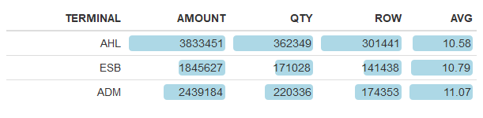

Table 3.2 Terminal

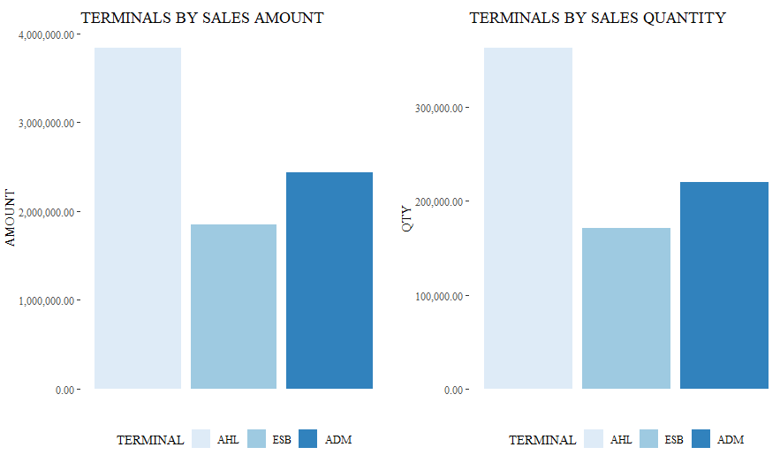

Figure 3.1 Terminal amount & qty

### Months

The dataset includes the first ten months of 2018 sales data for three cafes. February is the lowest amount and quantity value for all terminals. The highest amount month is September for AHL, on the other hand, August is the highest month for ADM and finally June for ESB. Qty and row values are formed in parallel with the Amount value. Row columns indicate a number of observations in Table 3.3. Even if it is not within the scope of this research, all the values occur the same way a seasonal number of passengers. The number of passengers increases towards to summer season in AHL and ADM because of the two cities prefer for the holidays by people. ESB has a different type of passenger portfolio. For this reason, ESB has a different pattern than the others in Figure 3.2. In the last column in Table 3.3, there is no meaning difference when looking at the AVG value.

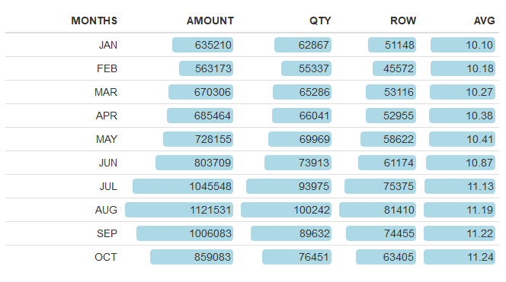

Table 3.3 Months

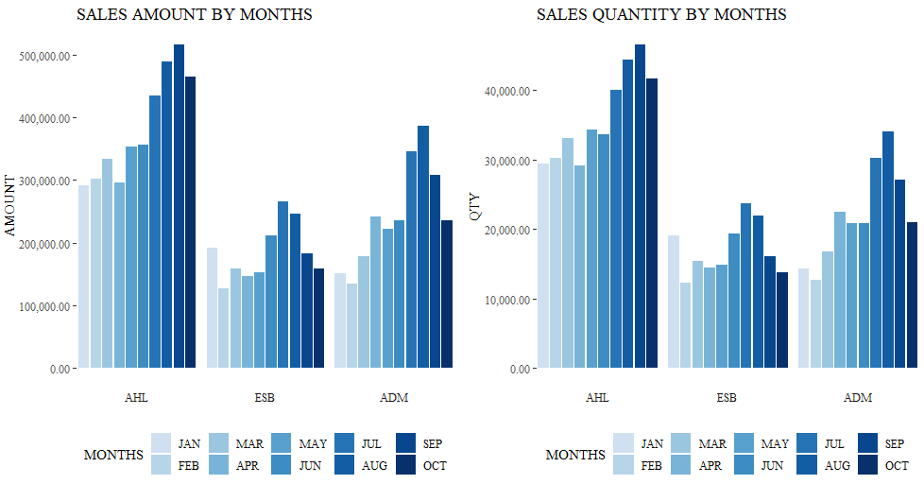

Figure 3.2 Month vs amount&qty facet terminal

### Day

Friday is the most profitable day according to first ten months sales data. All the values related to Friday are higher than the other days. At the same perspective, Friday is the most crowded day in all three terminals. It’s an obvious relationship between the sales amount, quantity etc and the number of passengers. In AHL, Monday is the second busiest day on weekdays. There is two steep points in all weekdays in AHL data. In ESB, Thursday is the second profitable day in a week. The weekend has the worst amount of sales in ESB. Saturday is the worst day in ADM. In ADM, Sunday is the second profitable day after the Friday.

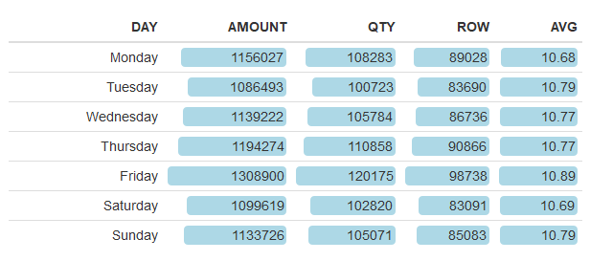

Table 3.4 Day

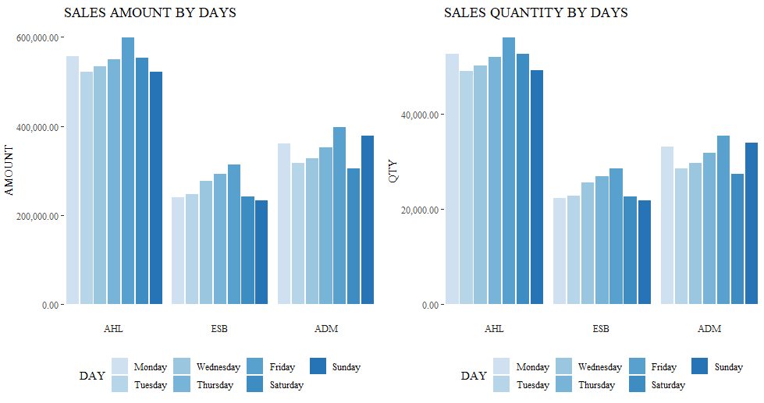

Figure 3.3 Day vs Amount&qty facet terminal

### Sales Categories

According to Table 3.5 Top ten sales category, “Sandviçler” is the most profitable one. But in quantity, “Çay Grubu” has the highest score and also the third highest amount score of the dataset. Despite the highest quantity of dataset, “Çay Grubu” has a very low average rate. It’s lower than half of the average rate of “Sandviçler”. Because of that “Çay Grubu” has the third highest category considering the amount score.

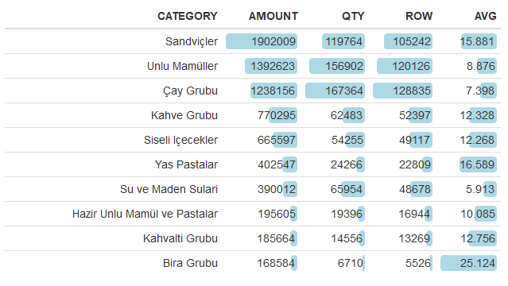

Table 3.5 Top ten sales category

When considering the terminal factor, we’ll find the same results despite one or two exceptions. Generally, in all the categories, AHL is the first, ADM is second and ESB is the third one. And the other interesting result is ADM has the highest amount in Kahvaltı Grubu. This inference can be further examined separately as the subject of another study. Because there are lots of reasons could because of this.

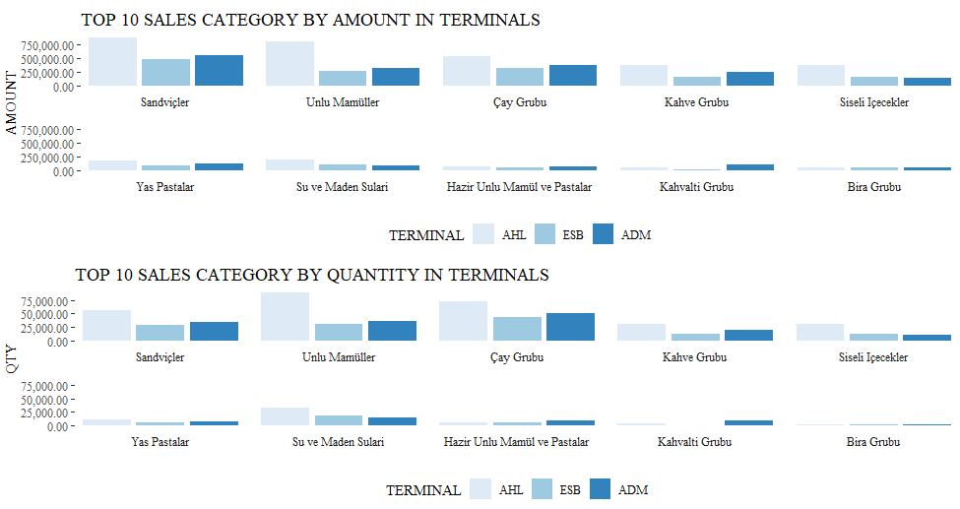

Figure 3.4 Terminal vs amount and quantity facet category

### Sales Products

As you see in Table 3.6 Top ten sales items, “ÇAY KÜÇÜK” is the best selling product among all products. It has the highest quantity score too. Average scores of first two top-selling products are between the lows rest of the table. “SANDVİÇ KABURGALI PEYNİRLİ” is the third product when considering the amount. Despite the low quantity value of that product, the highest average value carries it to third place. “SU PET ŞİŞE” is another product has a low average and high quantity value according to Table 3.6.

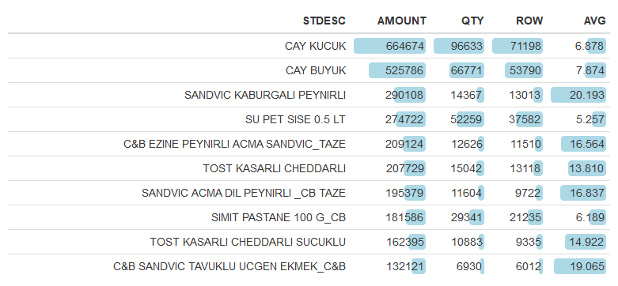

Table 3.6 Top ten sales items

When we look at the bottom six products of Table 3.6 Top ten sales items, “SİMİT PASTANE” has very high quantity value different than the other five items. In this section of the table, there are no beverage products and almost all of them belong to “Sandviçler” categories.

In Figure 3.5, among in three terminals, AHL has the highest amount and qty values for all ten products. ADM is the second highest terminal most of ten products. Despite the fact that “SIMIT PASTANE” has sold only in AHL it's in among the top ten products. “EZİNE PEYNİRLİ AÇMA” is the only product which has the highest amount and quantity value in ESB among all ten products. In AHL, the same product has the lowest value.

Lastly, there are three from “Çay Grubu” category, six products from “Sanviçler” category and one product from “Unlu” category in the top ten product tables. This result confirms that the two best-selling categories are “Çay Grubu” and “Sandviçler”.

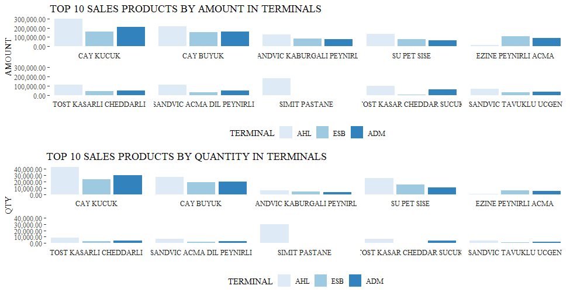

Figure 3.5 Terminal vs amount facet products

# METHODS

## Methodology

### CRISP-DM

The cross-industry standard process for data mining (CRISP-DM) is the name of our methodology to use in this study. CRISP-DM is an open source model which is contained to all approaches for a data mining process. CRISP-DM has six sequential phases each of them can trigger in a circular plane: Business Understanding, Data Understanding, Data Preparation, Modelling, Evaluation, and Deployment. The phases in CRISP-DM is not mandatory. The arrows in Figure 4.1 CRISP-DM Process Diagram shows the direction and relationship among the phases. Additionally, the outer circle of the CRISP-DM process diagram indicates the continuous nature of the process. Endless process continuously feeds itself from data and understanding [12].

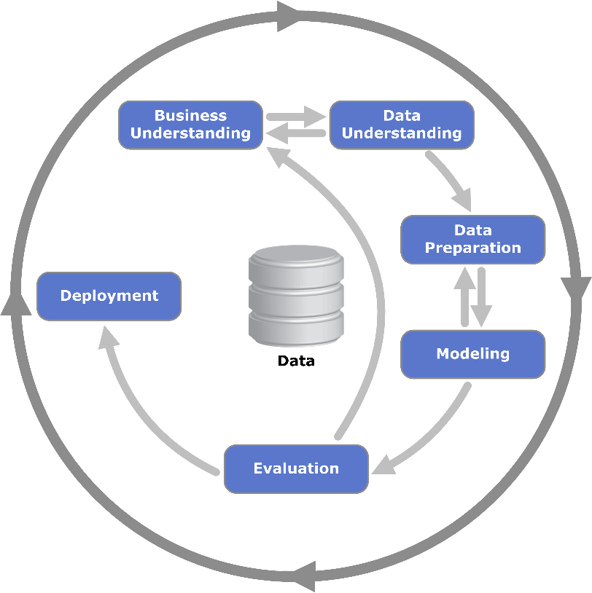

Figure 4.1 CRISP-DM Process Diagram [12]

# DATA ANALYSIS AND RESULTS

One of the aims of this study is finding product bundles which tend to buy together from the sales data of three cafes and through the results from here to create the cross-sell and up-sell opportunities. Additionally to apply all these methods to category dimension to aim to suggest a new menu structure for these cafes.

For this purpose, we used the Apriori algorithm which is the most common and famous algorithm in association rules mining. In this study mainly use this algorithm by the help of arules and arulesviz package in R. Apriori algorithm apply to two dimensions of dataset: product and category as we mentioned before.

In this section, basket analysis is performed on café sales data collected in the first ten months in 2018.

## Apriori Algorithm on Products

After the cleaning redundant data, a dataset consisting of 616.812 lines is used in this part of the analysis. The data includes 293.308 customer baskets. 351different products are classified in 30 sales categories. This part of the analysis is made on the basis of products. All data is stored as csv with the help of SQL. Then it was adapted to an analysis by R-Studio.

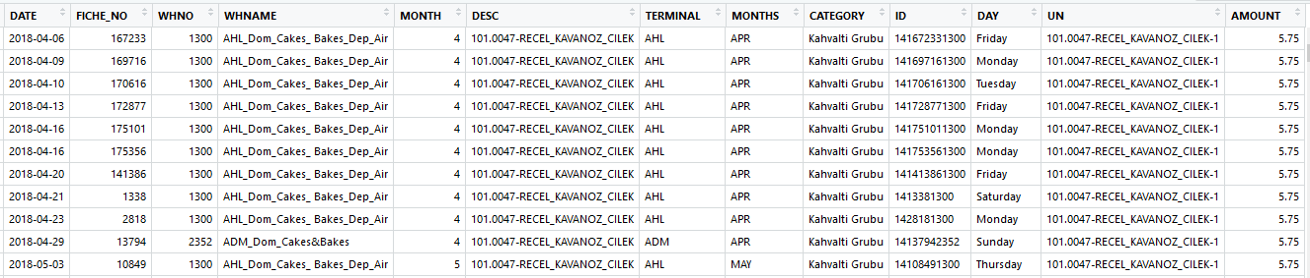

Figure 5.1 Product and categories

|  |
| --- |
| [1] "981780793310\n203.0031-SCHWEPPES_MANDALINA_250_ML-35"   [2] "981780793310\n105.0297-TOST_KASARLI_CHEDDARLI-5"   [3] "105171241300\n105.0506-SANDVIC_ACMA_DIL_PEYNIRLI__CB_TAZE-5"   [4] "105598683310\n119.0601-POGACA_EV_KASARLI_ZEYTINLI_CIG_75_G__C&B-19"   [5] "105171241300\n209.0013-MILLER-41"   [6] "105171241300\n209.0004-EFES_BIRA_YESIL_SISE-41"   [7] "105171241300\n209.0066-EFES_PILSEN_OZEL_SERI_NO:10_DONUSUMSUZ_50_CL-41"  [8] "105598683310\n119.0600-POGACA_EV_KIYMALI_CIG_75_G__C&B-19"   [9] "144171241300\n209.0084-EFES_BIRA_BOMONTI_BlACK_50_CL-41"  [10] "144171241300\n105.0598-C&B_SANDVIC_TON_BALIKLI_DNK-5" |

Figure 5.2 Transactions of products

As you can see in Figure 5.1 and Figure 5.2 data transformed to a suitable form of the association rules analysis. Figure 5.2 shows the transaction form of the data. R package ‘arules’ needs to data in this type form to run the association rule mining algorithms.

Figure 5.3 shows the top ten most sold products. For example, “ÇAY KÜÇÜK” is located in 20% of the whole shopping movement. Similarly, “SANDVİÇ KABURGALI PEYNİRLİ” are found in approximately 5% of all sales transactions.

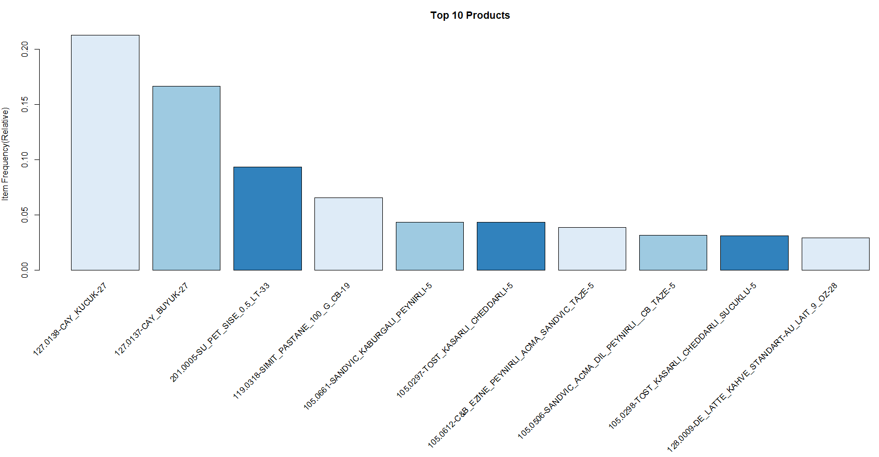

Figure 5.3 Top ten products

At the next stage, the outputs obtained as shown in Figure 5.4 give the association rules of the market data. This part of the analysis we should decide the minimum support and the minimum confidence values. Here, we determined the minimum support value 0.01 and minimum confidence value 0.05. This means that the algorithm did not select data below the threshold values mentioned above. After the rules occurred, was sorted by the support value. In addition, the rules were checked for statistical significance and redundant rules were excluded. In light of this information, Figure 5.4 shows the significance of 298 rules.

|  |
| --- |
| **LHS RHS support confidence lift count** [1] {127.0137-CAY_BUYUK-27} => {127.0138-CAY_KUCUK-27} 0.0553 0.332 1.56 16225 [2] {127.0138-CAY_KUCUK-27} => {127.0137-CAY_BUYUK-27} 0.0553 0.260 1.56 16225 [3] {105.0612-C&B_EZINE_PEYNIRLI_ACMA_SANDVIC_TAZE-5} => {127.0138-CAY_KUCUK-27} 0.0182 0.473 2.23 5352 [4] {127.0138-CAY_KUCUK-27} => {105.0612-C&B_EZINE_PEYNIRLI_ACMA_SANDVIC_TAZE-5} 0.0182 0.086 2.23 5352 [5] {105.0661-SANDVIC_KABURGALI_PEYNIRLI-5} => {127.0138-CAY_KUCUK-27} 0.0178 0.408 1.92 5213 [6] {127.0138-CAY_KUCUK-27} => {105.0661-SANDVIC_KABURGALI_PEYNIRLI-5} 0.0178 0.084 1.92 5213 [7] {105.0612-C&B_EZINE_PEYNIRLI_ACMA_SANDVIC_TAZE-5} => {127.0137-CAY_BUYUK-27} 0.0177 0.460 2.76 5209 [8] {127.0137-CAY_BUYUK-27} => {105.0612-C&B_EZINE_PEYNIRLI_ACMA_SANDVIC_TAZE-5} 0.0177 0.107 2.76 5209 [9] {105.0661-SANDVIC_KABURGALI_PEYNIRLI-5} => {127.0137-CAY_BUYUK-27} 0.0167 0.384 2.30 4897 [10] {127.0137-CAY_BUYUK-27} => {105.0661-SANDVIC_KABURGALI_PEYNIRLI-5} 0.0167 0.100 2.30 4897 [11] {105.0660-SANDVIC_PEYNIRLI_MINI_ESMER_EKMEKTE-5} => {127.0138-CAY_KUCUK-27} 0.0146 0.552 2.60 4275 [12] {127.0138-CAY_KUCUK-27} => {105.0660-SANDVIC_PEYNIRLI_MINI_ESMER_EKMEKTE-5} 0.0146 0.069 2.60 4275 [13] {201.0022-SU_CAM_SISE_OZEL_330_ML-33} => {201.0005-SU_PET_SISE_0.5_LT-33} 0.0106 0.609 6.52 3103 [14] {201.0005-SU_PET_SISE_0.5_LT-33} => {201.0022-SU_CAM_SISE_OZEL_330_ML-33} 0.0106 0.113 6.52 3103 [15] {105.0657-SANDVIC_JAMBONLU_ZERDECALLI_EKMEKTE-5} => {127.0138-CAY_KUCUK-27} 0.0104 0.470 2.21 3053 [16] {105.0662-SANDVIC_KRUVASAN_(CHEDAR_KASAR)-5} => {127.0138-CAY_KUCUK-27} 0.0098 0.463 2.18 2863 [17] {105.0660-SANDVIC_PEYNIRLI_MINI_ESMER_EKMEKTE-5} => {127.0137-CAY_BUYUK-27} 0.0094 0.356 2.14 2761 [18] {127.0137-CAY_BUYUK-27} => {105.0660-SANDVIC_PEYNIRLI_MINI_ESMER_EKMEKTE-5} 0.0094 0.056 2.14 2761 [19] {119.0882-C&B_KRUVASAN_CIKOLATALI_65_GRAM_CB_DNK-19} => {127.0138-CAY_KUCUK-27} 0.0089 0.434 2.04 2598 [20] {306.0498-TOST_MOZZARELLA_PEYNIRLI_KURUTULMUS_DOMATESLI_145_GR_C&B-64} => {127.0138-CAY_KUCUK-27} 0.0085 0.545 2.56 2490 [21] {105.0657-SANDVIC_JAMBONLU_ZERDECALLI_EKMEKTE-5} => {127.0137-CAY_BUYUK-27} 0.0084 0.381 2.28 2474 [22] {127.0137-CAY_BUYUK-27} => {105.0657-SANDVIC_JAMBONLU_ZERDECALLI_EKMEKTE-5} 0.0084 0.051 2.28 2474 [23] {105.0598-C&B_SANDVIC_TON_BALIKLI_DNK-5} => {127.0138-CAY_KUCUK-27} 0.0079 0.385 1.81 2309 [24] {105.0662-SANDVIC_KRUVASAN_(CHEDAR_KASAR)-5} => {127.0137-CAY_BUYUK-27} 0.0074 0.353 2.12 2181 [25] {128.0015-TURK_KAHVESI-28} => {201.0005-SU_PET_SISE_0.5_LT-33} 0.0074 0.635 6.79 2166 [26] {201.0005-SU_PET_SISE_0.5_LT-33} => {128.0015-TURK_KAHVESI-28} 0.0074 0.079 6.79 2166 [27] {105.0598-C&B_SANDVIC_TON_BALIKLI_DNK-5} => {127.0137-CAY_BUYUK-27} 0.0070 0.342 2.05 2051 [28] {119.0882-C&B_KRUVASAN_CIKOLATALI_65_GRAM_CB_DNK-19} => {127.0137-CAY_BUYUK-27} 0.0068 0.333 2.00 1994 [29] {306.0498-TOST_MOZZARELLA_PEYNIRLI_KURUTULMUS_DOMATESLI_145_GR_C&B-64} => {127.0137-CAY_BUYUK-27} 0.0065 0.415 2.49 1894 [30] {119.0162-MUFFIN_CIKOLATALI-19} => {201.0005-SU_PET_SISE_0.5_LT-33} 0.0061 0.709 7.58 1777 [31] {201.0005-SU_PET_SISE_0.5_LT-33} => {119.0162-MUFFIN_CIKOLATALI-19} 0.0061 0.065 7.58 1777 [32] {105.0297-TOST_KASARLI_CHEDDARLI-5} => {119.0318-SIMIT_PASTANE_100_G_CB-19} 0.0059 0.137 2.09 1745 [33] {119.0318-SIMIT_PASTANE_100_G_CB-19} => {105.0297-TOST_KASARLI_CHEDDARLI-5} 0.0059 0.091 2.09 1745 [34] {105.0658-CEKIRDEKLI_BAGEL_MOZARELLA-5} => {127.0138-CAY_KUCUK-27} 0.0059 0.441 2.08 1734 [35] {128.0009-DE_LATTE_KAHVE_STANDART-AU_LAIT_9_OZ-28} => {119.0318-SIMIT_PASTANE_100_G_CB-19} 0.0058 0.201 3.06 1706 [36] {119.0318-SIMIT_PASTANE_100_G_CB-19} => {128.0009-DE_LATTE_KAHVE_STANDART-AU_LAIT_9_OZ-28} 0.0058 0.089 3.06 1706 [37] {105.0658-CEKIRDEKLI_BAGEL_MOZARELLA-5} => {127.0137-CAY_BUYUK-27} 0.0056 0.418 2.51 1640 [38] {119.0883-C&B_KRUVASAN_BADEMLI_60_GRAM_CB_DNK-19} => {127.0138-CAY_KUCUK-27} 0.0052 0.419 1.97 1516 [39] {119.0163-MUFFIN_BERRYLI-19} => {201.0005-SU_PET_SISE_0.5_LT-33} 0.0048 0.671 7.18 1406 [40] {201.0005-SU_PET_SISE_0.5_LT-33} => {119.0163-MUFFIN_BERRYLI-19} 0.0048 0.051 7.18 1406 [41] {119.0883-C&B_KRUVASAN_BADEMLI_60_GRAM_CB_DNK-19} => {127.0137-CAY_BUYUK-27} 0.0043 0.349 2.09 1260 [42] {105.0298-TOST_KASARLI_CHEDDARLI_SUCUKLU-5} => {119.0318-SIMIT_PASTANE_100_G_CB-19} 0.0043 0.137 2.09 1248 [43] {119.0318-SIMIT_PASTANE_100_G_CB-19} => {105.0298-TOST_KASARLI_CHEDDARLI_SUCUKLU-5} 0.0043 0.065 2.09 1248 [44] {105.0298-TOST_KASARLI_CHEDDARLI_SUCUKLU-5} => {105.0297-TOST_KASARLI_CHEDDARLI-5} 0.0042 0.135 3.11 1231 [45] {105.0297-TOST_KASARLI_CHEDDARLI-5} => {105.0298-TOST_KASARLI_CHEDDARLI_SUCUKLU-5} 0.0042 0.097 3.11 1231 [46] {306.0497-TALAS_BOREGI_CB-64} => {127.0138-CAY_KUCUK-27} 0.0040 0.490 2.31 1179 [47] {119.0724-SARMA_PATATESLI_ACMA_C&B-19} => {119.0723-SARMA_PEYNIRLI_ACMA_C&B-19} 0.0039 0.252 12.54 1131 [48] {119.0723-SARMA_PEYNIRLI_ACMA_C&B-19} => {119.0724-SARMA_PATATESLI_ACMA_C&B-19} 0.0039 0.192 12.54 1131 [49] {105.0593-C&B_KIS_ISPANAKLI_PEYNIRLI_DNK-5} => {127.0138-CAY_KUCUK-27} 0.0038 0.432 2.03 1109 [50] {128.0001-DE_AMERICANO_9_OZ-28} => {119.0318-SIMIT_PASTANE_100_G_CB-19} 0.0037 0.188 2.86 1077 [51] {119.0318-SIMIT_PASTANE_100_G_CB-19} => {128.0001-DE_AMERICANO_9_OZ-28} 0.0037 0.056 2.86 1077 [52] {119.0619-BOREK_PATATESLI_RULO_CIG_85_GR_C&B-19} => {119.0617-BOREK_ISPANAKLI_RULO_CIG_85_GR_C&B-19} 0.0035 0.284 20.08 1023 [53] {119.0617-BOREK_ISPANAKLI_RULO_CIG_85_GR_C&B-19} => {119.0619-BOREK_PATATESLI_RULO_CIG_85_GR_C&B-19} 0.0035 0.247 20.08 1023 [54] {201.0007-SAN_PELEGRINO_200_ML-33} => {201.0005-SU_PET_SISE_0.5_LT-33} 0.0034 0.624 6.68 1008 [55] {203.0017-EXOTIC_PORTAKAL_330_ML-35} => {119.0318-SIMIT_PASTANE_100_G_CB-19} 0.0034 0.153 2.33 1002 [56] {119.0318-SIMIT_PASTANE_100_G_CB-19} => {203.0017-EXOTIC_PORTAKAL_330_ML-35} 0.0034 0.052 2.33 1002 [57] {128.0020-DE_FILTRE_KAHVE_ORTA_BOY_9_OZ-28} => {119.0318-SIMIT_PASTANE_100_G_CB-19} 0.0034 0.163 2.49 985 [58] {119.0318-SIMIT_PASTANE_100_G_CB-19} => {128.0020-DE_FILTRE_KAHVE_ORTA_BOY_9_OZ-28} 0.0034 0.051 2.49 985 [59] {203.0017-EXOTIC_PORTAKAL_330_ML-35} => {105.0297-TOST_KASARLI_CHEDDARLI-5} 0.0033 0.148 3.41 972 [60] {105.0297-TOST_KASARLI_CHEDDARLI-5} => {203.0017-EXOTIC_PORTAKAL_330_ML-35} 0.0033 0.076 3.41 972 [61] {128.0003-DE_CAPPUCCINO_9_OZ-28} => {119.0318-SIMIT_PASTANE_100_G_CB-19} 0.0033 0.179 2.73 971 [62] {119.0318-SIMIT_PASTANE_100_G_CB-19} => {128.0003-DE_CAPPUCCINO_9_OZ-28} 0.0033 0.050 2.73 971 [63] {105.0612-C&B_EZINE_PEYNIRLI_ACMA_SANDVIC_TAZE-5,   127.0137-CAY_BUYUK-27} => {127.0138-CAY_KUCUK-27} 0.0033 0.186 0.88 970 [64] {105.0612-C&B_EZINE_PEYNIRLI_ACMA_SANDVIC_TAZE-5,   127.0138-CAY_KUCUK-27} => {127.0137-CAY_BUYUK-27} 0.0033 0.181 1.09 970 [65] {127.0137-CAY_BUYUK-27,   127.0138-CAY_KUCUK-27} => {105.0612-C&B_EZINE_PEYNIRLI_ACMA_SANDVIC_TAZE-5} 0.0033 0.060 1.55 970 [66] {208.0001-AYRAN_KUTU_BUYUK-40} => {119.0318-SIMIT_PASTANE_100_G_CB-19} 0.0033 0.313 4.78 958 [67] {119.0374-KRUVASAN_SADE-19} => {119.0318-SIMIT_PASTANE_100_G_CB-19} 0.0032 0.182 2.78 943 [68] {105.0661-SANDVIC_KABURGALI_PEYNIRLI-5,   127.0137-CAY_BUYUK-27} => {127.0138-CAY_KUCUK-27} 0.0032 0.192 0.90 938 [69] {105.0661-SANDVIC_KABURGALI_PEYNIRLI-5,   127.0138-CAY_KUCUK-27} => {127.0137-CAY_BUYUK-27} 0.0032 0.180 1.08 938 [70] {127.0137-CAY_BUYUK-27,   127.0138-CAY_KUCUK-27} => {105.0661-SANDVIC_KABURGALI_PEYNIRLI-5} 0.0032 0.058 1.33 938 [71] {119.0886-C&B_KURABIYE_CEVIZLI_CIKOLATALI_COOKIES_50_GRAM_CB_DNK-19} => {127.0138-CAY_KUCUK-27} 0.0031 0.418 1.97 909 [72] {105.0450-C&B_SANDVIC_TAVUKLU_UCGEN_EKMEK_C&B-5} => {105.0506-SANDVIC_ACMA_DIL_PEYNIRLI__CB_TAZE-5} 0.0031 0.152 4.82 897 [73] {105.0506-SANDVIC_ACMA_DIL_PEYNIRLI__CB_TAZE-5} => {105.0450-C&B_SANDVIC_TAVUKLU_UCGEN_EKMEK_C&B-5} 0.0031 0.097 4.82 897 [74] {203.0005-COCA_COLA_SISE-35} => {119.0318-SIMIT_PASTANE_100_G_CB-19} 0.0030 0.166 2.53 895 [75] {306.0497-TALAS_BOREGI_CB-64} => {127.0137-CAY_BUYUK-27} 0.0030 0.371 2.23 892 [76] {119.0722-SARMA_ZEYTINLI_ACMA_C&B-19} => {119.0723-SARMA_PEYNIRLI_ACMA_C&B-19} 0.0030 0.221 10.98 884 [77] {119.0723-SARMA_PEYNIRLI_ACMA_C&B-19} => {119.0722-SARMA_ZEYTINLI_ACMA_C&B-19} 0.0030 0.150 10.98 884 [78] {105.0593-C&B_KIS_ISPANAKLI_PEYNIRLI_DNK-5} => {127.0137-CAY_BUYUK-27} 0.0030 0.342 2.05 878 [79] {120.0422-C&B_CHEESECAKE_OREO_NUTELLALI_10_DILIM_CB_DNK-20} => {127.0138-CAY_KUCUK-27} 0.0030 0.411 1.93 875 [80] {128.0001-DE_AMERICANO_9_OZ-28} => {128.0009-DE_LATTE_KAHVE_STANDART-AU_LAIT_9_OZ-28} 0.0029 0.148 5.10 847 [81] {128.0009-DE_LATTE_KAHVE_STANDART-AU_LAIT_9_OZ-28} => {128.0001-DE_AMERICANO_9_OZ-28} 0.0029 0.100 5.10 847 [82] {119.0618-BOREK_PEYNIRLI_RULO_CIG_85_GR_C&B-19} => {119.0617-BOREK_ISPANAKLI_RULO_CIG_85_GR_C&B-19} 0.0029 0.234 16.56 843 [83] {119.0617-BOREK_ISPANAKLI_RULO_CIG_85_GR_C&B-19} => {119.0618-BOREK_PEYNIRLI_RULO_CIG_85_GR_C&B-19} 0.0029 0.203 16.56 843 [84] {119.0884-C&B_KEK_UNSUZ_8_DILIM__CB_DNK-19} => {127.0138-CAY_KUCUK-27} 0.0028 0.439 2.07 829 [85] {119.0601-POGACA_EV_KASARLI_ZEYTINLI_CIG_75_G__C&B-19} => {119.0602-POGACA_EV_DEREOTLU_PEYNIRLI_KEPEKLI_CIG_100_GR_C&B-19} 0.0028 0.206 14.06 827 [86] {119.0602-POGACA_EV_DEREOTLU_PEYNIRLI_KEPEKLI_CIG_100_GR_C&B-19} => {119.0601-POGACA_EV_KASARLI_ZEYTINLI_CIG_75_G__C&B-19} 0.0028 0.192 14.06 827 [87] {101.0208-TOPPING_TULUM-1} => {306.0054-SIMIT_SADE-64} 0.0028 0.498 35.40 820 [88] {306.0054-SIMIT_SADE-64} => {101.0208-TOPPING_TULUM-1} 0.0028 0.199 35.40 820 [89] {128.0009-DE_LATTE_KAHVE_STANDART-AU_LAIT_9_OZ-28} => {105.0297-TOST_KASARLI_CHEDDARLI-5} 0.0028 0.096 2.21 817 [90] {105.0297-TOST_KASARLI_CHEDDARLI-5} => {128.0009-DE_LATTE_KAHVE_STANDART-AU_LAIT_9_OZ-28} 0.0028 0.064 2.21 817 [91] {120.0423-C&B_EKLER_CIKOLATALI_65_GRAM_CB_DNK-20} => {127.0138-CAY_KUCUK-27} 0.0027 0.435 2.05 805 [92] {119.0313-ACMA_SADE_%80_PISMIS_90_G_CB-19} => {119.0318-SIMIT_PASTANE_100_G_CB-19} 0.0027 0.400 6.10 805 [93] {203.0046-EXOTIC_ACIK_LIMONATA-35} => {119.0318-SIMIT_PASTANE_100_G_CB-19} 0.0027 0.236 3.59 803 [94] {120.0425-C&B_BROWNIE_75_GRAM_CB_DNK-20} => {127.0138-CAY_KUCUK-27} 0.0027 0.447 2.10 798 [95] {119.0188-TAHINLI_COREK_AHL_CC-19} => {119.0318-SIMIT_PASTANE_100_G_CB-19} 0.0027 0.336 5.12 785 [96] {120.0421-C&B_TART_YABAN_MERSINLI_10_DILIM_CB_DNK-20} => {127.0138-CAY_KUCUK-27} 0.0026 0.429 2.02 768 [97] {119.0722-SARMA_ZEYTINLI_ACMA_C&B-19} => {119.0724-SARMA_PATATESLI_ACMA_C&B-19} 0.0026 0.187 12.26 750 [98] {119.0724-SARMA_PATATESLI_ACMA_C&B-19} => {119.0722-SARMA_ZEYTINLI_ACMA_C&B-19} 0.0026 0.167 12.26 750 [99] {105.0660-SANDVIC_PEYNIRLI_MINI_ESMER_EKMEKTE-5,   127.0137-CAY_BUYUK-27} => {127.0138-CAY_KUCUK-27} 0.0025 0.271 1.27 748 [100] {105.0660-SANDVIC_PEYNIRLI_MINI_ESMER_EKMEKTE-5,   127.0138-CAY_KUCUK-27} => {127.0137-CAY_BUYUK-27} 0.0025 0.175 1.05 748 [101] {203.0005-COCA_COLA_SISE-35} => {105.0297-TOST_KASARLI_CHEDDARLI-5} 0.0025 0.137 3.15 738 [102] {105.0297-TOST_KASARLI_CHEDDARLI-5} => {203.0005-COCA_COLA_SISE-35} 0.0025 0.058 3.15 738 [103] {101.0231-KAHVALTI_TABAGI_KUCUK_HF-1} => {119.0318-SIMIT_PASTANE_100_G_CB-19} 0.0025 0.204 3.11 728 [104] {105.0598-C&B_SANDVIC_TON_BALIKLI_DNK-5} => {105.0661-SANDVIC_KABURGALI_PEYNIRLI-5} 0.0025 0.121 2.79 728 [105] {105.0661-SANDVIC_KABURGALI_PEYNIRLI-5} => {105.0598-C&B_SANDVIC_TON_BALIKLI_DNK-5} 0.0025 0.057 2.79 728 [106] {120.0422-C&B_CHEESECAKE_OREO_NUTELLALI_10_DILIM_CB_DNK-20} => {127.0137-CAY_BUYUK-27} 0.0024 0.336 2.01 714 [107] {128.0020-DE_FILTRE_KAHVE_ORTA_BOY_9_OZ-28} => {128.0009-DE_LATTE_KAHVE_STANDART-AU_LAIT_9_OZ-28} 0.0024 0.118 4.08 713 [108] {128.0009-DE_LATTE_KAHVE_STANDART-AU_LAIT_9_OZ-28} => {128.0020-DE_FILTRE_KAHVE_ORTA_BOY_9_OZ-28} 0.0024 0.084 4.08 713 [109] {119.0884-C&B_KEK_UNSUZ_8_DILIM__CB_DNK-19} => {127.0137-CAY_BUYUK-27} 0.0024 0.376 2.26 710 [110] {119.0618-BOREK_PEYNIRLI_RULO_CIG_85_GR_C&B-19} => {119.0619-BOREK_PATATESLI_RULO_CIG_85_GR_C&B-19} 0.0024 0.194 15.75 697 [111] {119.0619-BOREK_PATATESLI_RULO_CIG_85_GR_C&B-19} => {119.0618-BOREK_PEYNIRLI_RULO_CIG_85_GR_C&B-19} 0.0024 0.193 15.75 697 [112] {128.0022-DE_FILTRE_KAHVE_BUYUK_BOY_12_OZ-28} => {105.0297-TOST_KASARLI_CHEDDARLI-5} 0.0023 0.107 2.45 680 [113] {105.0297-TOST_KASARLI_CHEDDARLI-5} => {128.0022-DE_FILTRE_KAHVE_BUYUK_BOY_12_OZ-28} 0.0023 0.053 2.45 680 [114] {209.0059-EFES_BIRA_BOMONTI_FILTRESIZ_50_CL-41} => {201.0005-SU_PET_SISE_0.5_LT-33} 0.0023 0.590 6.31 677 [115] {119.0885-C&B_KURABIYE_FINDIKLI_CIKOLATALI_50_GRAM_CB_DNK-19} => {127.0138-CAY_KUCUK-27} 0.0022 0.381 1.79 659 [116] {203.0005-COCA_COLA_SISE-35} => {105.0298-TOST_KASARLI_CHEDDARLI_SUCUKLU-5} 0.0022 0.121 3.89 652 [117] {105.0298-TOST_KASARLI_CHEDDARLI_SUCUKLU-5} => {203.0005-COCA_COLA_SISE-35} 0.0022 0.072 3.89 652 [118] {128.0020-DE_FILTRE_KAHVE_ORTA_BOY_9_OZ-28} => {105.0297-TOST_KASARLI_CHEDDARLI-5} 0.0021 0.104 2.40 629 [119] {203.0017-EXOTIC_PORTAKAL_330_ML-35} => {105.0298-TOST_KASARLI_CHEDDARLI_SUCUKLU-5} 0.0021 0.095 3.07 627 [120] {105.0298-TOST_KASARLI_CHEDDARLI_SUCUKLU-5} => {203.0017-EXOTIC_PORTAKAL_330_ML-35} 0.0021 0.069 3.07 627 [121] {203.0020-EXOTIC_NAR-PORTAKAL_330_ML-35} => {119.0318-SIMIT_PASTANE_100_G_CB-19} 0.0021 0.178 2.71 624 [122] {128.0003-DE_CAPPUCCINO_9_OZ-28} => {128.0009-DE_LATTE_KAHVE_STANDART-AU_LAIT_9_OZ-28} 0.0021 0.114 3.94 620 [123] {128.0009-DE_LATTE_KAHVE_STANDART-AU_LAIT_9_OZ-28} => {128.0003-DE_CAPPUCCINO_9_OZ-28} 0.0021 0.073 3.94 620 [124] {105.0659-PITA_HINDI_FUME-5} => {127.0138-CAY_KUCUK-27} 0.0021 0.408 1.92 619 [125] {105.0657-SANDVIC_JAMBONLU_ZERDECALLI_EKMEKTE-5,   127.0137-CAY_BUYUK-27} => {127.0138-CAY_KUCUK-27} 0.0021 0.249 1.17 615 [126] {105.0657-SANDVIC_JAMBONLU_ZERDECALLI_EKMEKTE-5,   127.0138-CAY_KUCUK-27} => {127.0137-CAY_BUYUK-27} 0.0021 0.201 1.21 615 [127] {120.0423-C&B_EKLER_CIKOLATALI_65_GRAM_CB_DNK-20} => {127.0137-CAY_BUYUK-27} 0.0021 0.332 1.99 614 [128] {128.0022-DE_FILTRE_KAHVE_BUYUK_BOY_12_OZ-28} => {119.0318-SIMIT_PASTANE_100_G_CB-19} 0.0021 0.096 1.46 613 [129] {105.0612-C&B_EZINE_PEYNIRLI_ACMA_SANDVIC_TAZE-5} => {105.0661-SANDVIC_KABURGALI_PEYNIRLI-5} 0.0021 0.054 1.24 612 [130] {120.0421-C&B_TART_YABAN_MERSINLI_10_DILIM_CB_DNK-20} => {127.0137-CAY_BUYUK-27} 0.0021 0.340 2.04 609 [131] {120.0419-C&B_PASTA_KUCUK_DOME_CIKOLATALI_KARAMELI_115_GRAM_CB_DNK-20} => {127.0138-CAY_KUCUK-27} 0.0021 0.436 2.05 603 [132] {119.0581-KURU_PASTA_BOREKAS_PEYNIRLI_TUZLU-19} => {119.0579-KURU_PASTA_BOREKAS_KIYMALI_C&B-19} 0.0020 0.322 52.95 598 [133] {119.0579-KURU_PASTA_BOREKAS_KIYMALI_C&B-19} => {119.0581-KURU_PASTA_BOREKAS_PEYNIRLI_TUZLU-19} 0.0020 0.335 52.95 598 [134] {119.0886-C&B_KURABIYE_CEVIZLI_CIKOLATALI_COOKIES_50_GRAM_CB_DNK-19} => {127.0137-CAY_BUYUK-27} 0.0020 0.274 1.65 597 [135] {105.0659-PITA_HINDI_FUME-5} => {127.0137-CAY_BUYUK-27} 0.0020 0.389 2.33 589 [136] {203.0019-EXOTIC_HAVUC-PORTAKAL_330_ML-35} => {119.0318-SIMIT_PASTANE_100_G_CB-19} 0.0020 0.172 2.62 587 [137] {105.0657-SANDVIC_JAMBONLU_ZERDECALLI_EKMEKTE-5} => {105.0661-SANDVIC_KABURGALI_PEYNIRLI-5} 0.0020 0.088 2.03 573 [138] {128.0001-DE_AMERICANO_9_OZ-28} => {105.0297-TOST_KASARLI_CHEDDARLI-5} 0.0019 0.099 2.27 566 [139] {131.0222-BEYAZ_PEYNIR_EZINE_C&B-31} => {306.0054-SIMIT_SADE-64} 0.0019 0.351 24.93 556 [140] {306.0054-SIMIT_SADE-64} => {131.0222-BEYAZ_PEYNIR_EZINE_C&B-31} 0.0019 0.135 24.93 556 [141] {101.0194-YUMURTA_HASLANMIS-1} => {119.0038-BOYOZ-19} 0.0019 0.263 24.48 548 [142] {119.0038-BOYOZ-19} => {101.0194-YUMURTA_HASLANMIS-1} 0.0019 0.173 24.48 548 [143] {120.0425-C&B_BROWNIE_75_GRAM_CB_DNK-20} => {127.0137-CAY_BUYUK-27} 0.0018 0.303 1.82 540 [144] {119.0723-SARMA_PEYNIRLI_ACMA_C&B-19} => {105.0506-SANDVIC_ACMA_DIL_PEYNIRLI__CB_TAZE-5} 0.0018 0.091 2.88 538 [145] {105.0506-SANDVIC_ACMA_DIL_PEYNIRLI__CB_TAZE-5} => {119.0723-SARMA_PEYNIRLI_ACMA_C&B-19} 0.0018 0.058 2.88 538 [146] {119.0600-POGACA_EV_KIYMALI_CIG_75_G__C&B-19} => {119.0601-POGACA_EV_KASARLI_ZEYTINLI_CIG_75_G__C&B-19} 0.0018 0.204 14.92 536 [147] {119.0601-POGACA_EV_KASARLI_ZEYTINLI_CIG_75_G__C&B-19} => {119.0600-POGACA_EV_KIYMALI_CIG_75_G__C&B-19} 0.0018 0.133 14.92 536 [148] {126.0045-LIMONATA_ACIK-26} => {105.0298-TOST_KASARLI_CHEDDARLI_SUCUKLU-5} 0.0018 0.163 5.26 534 [149] {105.0298-TOST_KASARLI_CHEDDARLI_SUCUKLU-5} => {126.0045-LIMONATA_ACIK-26} 0.0018 0.059 5.26 534 [150] {105.0662-SANDVIC_KRUVASAN_(CHEDAR_KASAR)-5} => {105.0661-SANDVIC_KABURGALI_PEYNIRLI-5} 0.0018 0.086 1.97 531 [151] {208.0003-SUT_1/5_SADE-40} => {119.0318-SIMIT_PASTANE_100_G_CB-19} 0.0018 0.199 3.04 523 [152] {203.0040-COCA_COLA_ZERO_SISE-35} => {105.0297-TOST_KASARLI_CHEDDARLI-5} 0.0018 0.133 3.05 518 [153] {119.0885-C&B_KURABIYE_FINDIKLI_CIKOLATALI_50_GRAM_CB_DNK-19} => {127.0137-CAY_BUYUK-27} 0.0018 0.297 1.79 514 [154] {128.0003-DE_CAPPUCCINO_9_OZ-28} => {128.0001-DE_AMERICANO_9_OZ-28} 0.0018 0.095 4.85 514 [155] {128.0001-DE_AMERICANO_9_OZ-28} => {128.0003-DE_CAPPUCCINO_9_OZ-28} 0.0018 0.090 4.85 514 [156] {208.0036-AYRAN_NANELI_TETRAPAK_330ML-40} => {105.0506-SANDVIC_ACMA_DIL_PEYNIRLI__CB_TAZE-5} 0.0017 0.171 5.40 512 [157] {105.0506-SANDVIC_ACMA_DIL_PEYNIRLI__CB_TAZE-5} => {208.0036-AYRAN_NANELI_TETRAPAK_330ML-40} 0.0017 0.055 5.40 512 [158] {203.0103-CAPPY_%100_ELMA_CAM_SISE_250_CL-35} => {119.0318-SIMIT_PASTANE_100_G_CB-19} 0.0017 0.148 2.26 510 [159] {123.0085-TIRAMISU_BARDAKTA_C&B-23} => {127.0138-CAY_KUCUK-27} 0.0017 0.430 2.02 505 [160] {127.0137-CAY_BUYUK-27,   306.0498-TOST_MOZZARELLA_PEYNIRLI_KURUTULMUS_DOMATESLI_145_GR_C&B-64} => {127.0138-CAY_KUCUK-27} 0.0017 0.265 1.25 502 [161] {127.0138-CAY_KUCUK-27,   306.0498-TOST_MOZZARELLA_PEYNIRLI_KURUTULMUS_DOMATESLI_145_GR_C&B-64} => {127.0137-CAY_BUYUK-27} 0.0017 0.202 1.21 502 [162] {119.0883-C&B_KRUVASAN_BADEMLI_60_GRAM_CB_DNK-19} => {119.0882-C&B_KRUVASAN_CIKOLATALI_65_GRAM_CB_DNK-19} 0.0017 0.138 6.77 499 [163] {119.0882-C&B_KRUVASAN_CIKOLATALI_65_GRAM_CB_DNK-19} => {119.0883-C&B_KRUVASAN_BADEMLI_60_GRAM_CB_DNK-19} 0.0017 0.083 6.77 499 [164] {128.0022-DE_FILTRE_KAHVE_BUYUK_BOY_12_OZ-28} => {105.0298-TOST_KASARLI_CHEDDARLI_SUCUKLU-5} 0.0017 0.078 2.50 495 [165] {105.0298-TOST_KASARLI_CHEDDARLI_SUCUKLU-5} => {128.0022-DE_FILTRE_KAHVE_BUYUK_BOY_12_OZ-28} 0.0017 0.054 2.50 495 [166] {203.0102-FUSE_TEA_SEFTALI_CAM_SISE_250_CL-35} => {119.0318-SIMIT_PASTANE_100_G_CB-19} 0.0017 0.148 2.25 491 [167] {105.0662-SANDVIC_KRUVASAN_(CHEDAR_KASAR)-5,   127.0137-CAY_BUYUK-27} => {127.0138-CAY_KUCUK-27} 0.0017 0.224 1.05 489 [168] {105.0662-SANDVIC_KRUVASAN_(CHEDAR_KASAR)-5,   127.0138-CAY_KUCUK-27} => {127.0137-CAY_BUYUK-27} 0.0017 0.171 1.03 489 [169] {119.0169-HAVUCLU_KEK_KEPEKLI_10_DILIM_AHL-19} => {119.0318-SIMIT_PASTANE_100_G_CB-19} 0.0017 0.184 2.80 488 [170] {119.0374-KRUVASAN_SADE-19} => {128.0009-DE_LATTE_KAHVE_STANDART-AU_LAIT_9_OZ-28} 0.0017 0.094 3.26 488 [171] {128.0009-DE_LATTE_KAHVE_STANDART-AU_LAIT_9_OZ-28} => {119.0374-KRUVASAN_SADE-19} 0.0017 0.057 3.26 488 [172] {101.0194-YUMURTA_HASLANMIS-1} => {101.0231-KAHVALTI_TABAGI_KUCUK_HF-1} 0.0016 0.233 19.12 484 [173] {101.0231-KAHVALTI_TABAGI_KUCUK_HF-1} => {101.0194-YUMURTA_HASLANMIS-1} 0.0016 0.135 19.12 484 [174] {203.0019-EXOTIC_HAVUC-PORTAKAL_330_ML-35} => {105.0297-TOST_KASARLI_CHEDDARLI-5} 0.0016 0.141 3.26 484 [175] {208.0001-AYRAN_KUTU_BUYUK-40} => {105.0297-TOST_KASARLI_CHEDDARLI-5} 0.0016 0.158 3.63 482 [176] {208.0036-AYRAN_NANELI_TETRAPAK_330ML-40} => {105.0450-C&B_SANDVIC_TAVUKLU_UCGEN_EKMEK_C&B-5} 0.0016 0.161 8.01 481 [177] {105.0450-C&B_SANDVIC_TAVUKLU_UCGEN_EKMEK_C&B-5} => {208.0036-AYRAN_NANELI_TETRAPAK_330ML-40} 0.0016 0.082 8.01 481 [178] {128.0217-DE_AMERICANO_12_OZ-28} => {128.0219-DE_LATTE_KAHVE_STANDART-AU_LAIT_12_OZ-28} 0.0016 0.160 11.72 480 [179] {128.0219-DE_LATTE_KAHVE_STANDART-AU_LAIT_12_OZ-28} => {128.0217-DE_AMERICANO_12_OZ-28} 0.0016 0.120 11.72 480 [180] {203.0040-COCA_COLA_ZERO_SISE-35} => {119.0318-SIMIT_PASTANE_100_G_CB-19} 0.0016 0.123 1.87 479 [181] {203.0102-FUSE_TEA_SEFTALI_CAM_SISE_250_CL-35} => {105.0297-TOST_KASARLI_CHEDDARLI-5} 0.0016 0.143 3.28 474 [182] {105.0660-SANDVIC_PEYNIRLI_MINI_ESMER_EKMEKTE-5} => {105.0661-SANDVIC_KABURGALI_PEYNIRLI-5} 0.0016 0.061 1.40 471 [183] {208.0001-AYRAN_KUTU_BUYUK-40} => {105.0298-TOST_KASARLI_CHEDDARLI_SUCUKLU-5} 0.0016 0.154 4.95 470 [184] {105.0298-TOST_KASARLI_CHEDDARLI_SUCUKLU-5} => {208.0001-AYRAN_KUTU_BUYUK-40} 0.0016 0.052 4.95 470 [185] {128.0009-DE_LATTE_KAHVE_STANDART-AU_LAIT_9_OZ-28} => {105.0298-TOST_KASARLI_CHEDDARLI_SUCUKLU-5} 0.0016 0.055 1.77 467 [186] {105.0298-TOST_KASARLI_CHEDDARLI_SUCUKLU-5} => {128.0009-DE_LATTE_KAHVE_STANDART-AU_LAIT_9_OZ-28} 0.0016 0.051 1.77 467 [187] {119.0677-MACARON_BOGURTLENLI_CB-19} => {119.0668-MACARON_FRAMBUAZLI_CB-19} 0.0016 0.631 225.29 465 [188] {119.0668-MACARON_FRAMBUAZLI_CB-19} => {119.0677-MACARON_BOGURTLENLI_CB-19} 0.0016 0.566 225.29 465 [189] {108.0073-GURCU_PIDE_PEYNIRLI-8} => {108.0071-GURCU_PIDE_KIYMALI-8} 0.0016 0.157 13.97 465 [190] {108.0071-GURCU_PIDE_KIYMALI-8} => {108.0073-GURCU_PIDE_PEYNIRLI-8} 0.0016 0.141 13.97 465 [191] {203.0103-CAPPY_%100_ELMA_CAM_SISE_250_CL-35} => {105.0297-TOST_KASARLI_CHEDDARLI-5} 0.0016 0.134 3.09 462 [192] {126.0045-LIMONATA_ACIK-26} => {105.0297-TOST_KASARLI_CHEDDARLI-5} 0.0016 0.139 3.21 456 [193] {203.0046-EXOTIC_ACIK_LIMONATA-35} => {105.0297-TOST_KASARLI_CHEDDARLI-5} 0.0016 0.134 3.08 455 [194] {203.0020-EXOTIC_NAR-PORTAKAL_330_ML-35} => {105.0297-TOST_KASARLI_CHEDDARLI-5} 0.0016 0.130 2.98 455 [195] {108.0073-GURCU_PIDE_PEYNIRLI-8} => {119.0318-SIMIT_PASTANE_100_G_CB-19} 0.0015 0.153 2.34 454 [196] {105.0525-SANDVIC_MINI_JAMBONLU_CB-5} => {105.0506-SANDVIC_ACMA_DIL_PEYNIRLI__CB_TAZE-5} 0.0015 0.212 6.70 450 [197] {128.0003-DE_CAPPUCCINO_9_OZ-28} => {105.0297-TOST_KASARLI_CHEDDARLI-5} 0.0015 0.082 1.89 445 [198] {119.0374-KRUVASAN_SADE-19} => {105.0297-TOST_KASARLI_CHEDDARLI-5} 0.0015 0.085 1.96 441 [199] {119.0168-HAVUCLU_KEK_10_DILIM_DEKORLU_AHL-19} => {119.0318-SIMIT_PASTANE_100_G_CB-19} 0.0015 0.161 2.45 439 [200] {119.0665-MACARON_CIKOLATALI_CB-19} => {119.0668-MACARON_FRAMBUAZLI_CB-19} 0.0015 0.574 204.97 438 [201] {119.0668-MACARON_FRAMBUAZLI_CB-19} => {119.0665-MACARON_CIKOLATALI_CB-19} 0.0015 0.533 204.97 438 [202] {120.0419-C&B_PASTA_KUCUK_DOME_CIKOLATALI_KARAMELI_115_GRAM_CB_DNK-20} => {127.0137-CAY_BUYUK-27} 0.0015 0.317 1.90 438 [203] {119.0882-C&B_KRUVASAN_CIKOLATALI_65_GRAM_CB_DNK-19,   127.0137-CAY_BUYUK-27} => {127.0138-CAY_KUCUK-27} 0.0015 0.219 1.03 437 [204] {119.0882-C&B_KRUVASAN_CIKOLATALI_65_GRAM_CB_DNK-19,   127.0138-CAY_KUCUK-27} => {127.0137-CAY_BUYUK-27} 0.0015 0.168 1.01 437 [205] {208.0035-AYRAN_SADE_TETRAPAK_330ML-40} => {105.0506-SANDVIC_ACMA_DIL_PEYNIRLI__CB_TAZE-5} 0.0014 0.143 4.53 415 [206] {119.0163-MUFFIN_BERRYLI-19} => {119.0162-MUFFIN_CIKOLATALI-19} 0.0014 0.197 23.09 413 [207] {119.0162-MUFFIN_CIKOLATALI-19} => {119.0163-MUFFIN_BERRYLI-19} 0.0014 0.165 23.09 413 [208] {108.0071-GURCU_PIDE_KIYMALI-8} => {119.0318-SIMIT_PASTANE_100_G_CB-19} 0.0014 0.125 1.91 413 [209] {110.0107-PIZZA_EKMEK_USTU_SARKUTERILI_CB-10} => {110.0106-PIZZA_EKMEK_USTU_AKDENIZ_CB-10} 0.0014 0.180 22.18 410 [210] {110.0106-PIZZA_EKMEK_USTU_AKDENIZ_CB-10} => {110.0107-PIZZA_EKMEK_USTU_SARKUTERILI_CB-10} 0.0014 0.173 22.18 410 [211] {101.0231-KAHVALTI_TABAGI_KUCUK_HF-1} => {306.0054-SIMIT_SADE-64} 0.0014 0.115 8.16 410 [212] {306.0054-SIMIT_SADE-64} => {101.0231-KAHVALTI_TABAGI_KUCUK_HF-1} 0.0014 0.099 8.16 410 [213] {119.0374-KRUVASAN_SADE-19} => {203.0017-EXOTIC_PORTAKAL_330_ML-35} 0.0014 0.079 3.54 410 [214] {203.0017-EXOTIC_PORTAKAL_330_ML-35} => {119.0374-KRUVASAN_SADE-19} 0.0014 0.062 3.54 410 [215] {203.0020-EXOTIC_NAR-PORTAKAL_330_ML-35} => {203.0017-EXOTIC_PORTAKAL_330_ML-35} 0.0014 0.116 5.21 409 [216] {203.0017-EXOTIC_PORTAKAL_330_ML-35} => {203.0020-EXOTIC_NAR-PORTAKAL_330_ML-35} 0.0014 0.062 5.21 409 [217] {119.0600-POGACA_EV_KIYMALI_CIG_75_G__C&B-19} => {119.0602-POGACA_EV_DEREOTLU_PEYNIRLI_KEPEKLI_CIG_100_GR_C&B-19} 0.0014 0.155 10.56 406 [218] {119.0602-POGACA_EV_DEREOTLU_PEYNIRLI_KEPEKLI_CIG_100_GR_C&B-19} => {119.0600-POGACA_EV_KIYMALI_CIG_75_G__C&B-19} 0.0014 0.094 10.56 406 [219] {208.0035-AYRAN_SADE_TETRAPAK_330ML-40} => {105.0450-C&B_SANDVIC_TAVUKLU_UCGEN_EKMEK_C&B-5} 0.0014 0.139 6.95 403 [220] {105.0450-C&B_SANDVIC_TAVUKLU_UCGEN_EKMEK_C&B-5} => {208.0035-AYRAN_SADE_TETRAPAK_330ML-40} 0.0014 0.069 6.95 403 [221] {120.0219-TART_CILEKLI_BUYUK_290_G_CB-20} => {119.0318-SIMIT_PASTANE_100_G_CB-19} 0.0014 0.104 1.58 400 [222] {119.0038-BOYOZ-19} => {306.0054-SIMIT_SADE-64} 0.0014 0.126 8.98 399 [223] {306.0054-SIMIT_SADE-64} => {119.0038-BOYOZ-19} 0.0014 0.097 8.98 399 [224] {203.0040-COCA_COLA_ZERO_SISE-35} => {105.0298-TOST_KASARLI_CHEDDARLI_SUCUKLU-5} 0.0014 0.102 3.29 399 [225] {128.0003-DE_CAPPUCCINO_9_OZ-28} => {119.0374-KRUVASAN_SADE-19} 0.0013 0.073 4.14 396 [226] {119.0374-KRUVASAN_SADE-19} => {128.0003-DE_CAPPUCCINO_9_OZ-28} 0.0013 0.077 4.14 396 [227] {203.0017-EXOTIC_PORTAKAL_330_ML-35} => {128.0009-DE_LATTE_KAHVE_STANDART-AU_LAIT_9_OZ-28} 0.0013 0.060 2.07 393 [228] {119.0882-C&B_KRUVASAN_CIKOLATALI_65_GRAM_CB_DNK-19} => {105.0661-SANDVIC_KABURGALI_PEYNIRLI-5} 0.0013 0.065 1.50 392 [229] {119.0677-MACARON_BOGURTLENLI_CB-19} => {119.0665-MACARON_CIKOLATALI_CB-19} 0.0013 0.531 204.08 391 [230] {119.0665-MACARON_CIKOLATALI_CB-19} => {119.0677-MACARON_BOGURTLENLI_CB-19} 0.0013 0.512 204.08 391 [231] {119.0722-SARMA_ZEYTINLI_ACMA_C&B-19} => {105.0506-SANDVIC_ACMA_DIL_PEYNIRLI__CB_TAZE-5} 0.0013 0.097 3.06 388 [232] {203.0102-FUSE_TEA_SEFTALI_CAM_SISE_250_CL-35} => {105.0298-TOST_KASARLI_CHEDDARLI_SUCUKLU-5} 0.0013 0.116 3.75 387 [233] {101.0231-KAHVALTI_TABAGI_KUCUK_HF-1} => {105.0297-TOST_KASARLI_CHEDDARLI-5} 0.0013 0.108 2.50 387 [234] {123.0085-TIRAMISU_BARDAKTA_C&B-23} => {127.0137-CAY_BUYUK-27} 0.0013 0.328 1.97 385 [235] {203.0019-EXOTIC_HAVUC-PORTAKAL_330_ML-35} => {203.0017-EXOTIC_PORTAKAL_330_ML-35} 0.0013 0.112 5.02 384 [236] {203.0017-EXOTIC_PORTAKAL_330_ML-35} => {203.0019-EXOTIC_HAVUC-PORTAKAL_330_ML-35} 0.0013 0.058 5.02 384 [237] {128.0022-DE_FILTRE_KAHVE_BUYUK_BOY_12_OZ-28} => {128.0009-DE_LATTE_KAHVE_STANDART-AU_LAIT_9_OZ-28} 0.0013 0.060 2.07 382 [238] {123.0084-MEYVELI_KUP-23} => {127.0138-CAY_KUCUK-27} 0.0013 0.445 2.09 376 [239] {209.0004-EFES_BIRA_YESIL_SISE-41} => {201.0005-SU_PET_SISE_0.5_LT-33} 0.0013 0.565 6.04 375 [240] {131.0222-BEYAZ_PEYNIR_EZINE_C&B-31} => {119.0318-SIMIT_PASTANE_100_G_CB-19} 0.0013 0.235 3.59 373 [241] {128.0003-DE_CAPPUCCINO_9_OZ-28} => {128.0020-DE_FILTRE_KAHVE_ORTA_BOY_9_OZ-28} 0.0013 0.068 3.32 371 [242] {128.0020-DE_FILTRE_KAHVE_ORTA_BOY_9_OZ-28} => {128.0003-DE_CAPPUCCINO_9_OZ-28} 0.0013 0.061 3.32 371 [243] {119.0885-C&B_KURABIYE_FINDIKLI_CIKOLATALI_50_GRAM_CB_DNK-19} => {119.0886-C&B_KURABIYE_CEVIZLI_CIKOLATALI_COOKIES_50_GRAM_CB_DNK-19} 0.0013 0.214 28.80 369 [244] {119.0886-C&B_KURABIYE_CEVIZLI_CIKOLATALI_COOKIES_50_GRAM_CB_DNK-19} => {119.0885-C&B_KURABIYE_FINDIKLI_CIKOLATALI_50_GRAM_CB_DNK-19} 0.0013 0.170 28.80 369 [245] {120.0219-TART_CILEKLI_BUYUK_290_G_CB-20} => {128.0022-DE_FILTRE_KAHVE_BUYUK_BOY_12_OZ-28} 0.0013 0.095 4.38 368 [246] {128.0022-DE_FILTRE_KAHVE_BUYUK_BOY_12_OZ-28} => {120.0219-TART_CILEKLI_BUYUK_290_G_CB-20} 0.0013 0.058 4.38 368 [247] {105.0598-C&B_SANDVIC_TON_BALIKLI_DNK-5,   127.0137-CAY_BUYUK-27} => {127.0138-CAY_KUCUK-27} 0.0013 0.179 0.84 368 [248] {105.0598-C&B_SANDVIC_TON_BALIKLI_DNK-5,   127.0138-CAY_KUCUK-27} => {127.0137-CAY_BUYUK-27} 0.0013 0.159 0.96 368 [249] {202.0048-CAPPY_KARISIK_MEYVE_CAM_SISE_250_ML-34} => {105.0377-SANDVIC_SIMIT_PASTANE_EZINE_PEYNIRLI-5} 0.0012 0.249 35.70 366 [250] {105.0377-SANDVIC_SIMIT_PASTANE_EZINE_PEYNIRLI-5} => {202.0048-CAPPY_KARISIK_MEYVE_CAM_SISE_250_ML-34} 0.0012 0.179 35.70 366 [251] {105.0503-TOST_SEBZELI_KECI_PEYNIRLI_TAHILLI_KOY_EKMEK-5} => {105.0506-SANDVIC_ACMA_DIL_PEYNIRLI__CB_TAZE-5} 0.0012 0.131 4.13 360 [252] {101.0194-YUMURTA_HASLANMIS-1} => {306.0054-SIMIT_SADE-64} 0.0012 0.173 12.27 359 [253] {306.0054-SIMIT_SADE-64} => {101.0194-YUMURTA_HASLANMIS-1} 0.0012 0.087 12.27 359 [254] {203.0004-COCA_COLA_LIGHT_SISE-35} => {119.0318-SIMIT_PASTANE_100_G_CB-19} 0.0012 0.140 2.13 358 [255] {128.0219-DE_LATTE_KAHVE_STANDART-AU_LAIT_12_OZ-28} => {105.0506-SANDVIC_ACMA_DIL_PEYNIRLI__CB_TAZE-5} 0.0012 0.089 2.82 358 [256] {208.0003-SUT_1/5_SADE-40} => {105.0297-TOST_KASARLI_CHEDDARLI-5} 0.0012 0.133 3.07 350 [257] {120.0219-TART_CILEKLI_BUYUK_290_G_CB-20} => {128.0009-DE_LATTE_KAHVE_STANDART-AU_LAIT_9_OZ-28} 0.0012 0.090 3.10 347 [258] {128.0001-DE_AMERICANO_9_OZ-28} => {105.0298-TOST_KASARLI_CHEDDARLI_SUCUKLU-5} 0.0012 0.060 1.94 346 [259] {105.0657-SANDVIC_JAMBONLU_ZERDECALLI_EKMEKTE-5} => {105.0660-SANDVIC_PEYNIRLI_MINI_ESMER_EKMEKTE-5} 0.0012 0.053 2.00 344 [260] {203.0004-COCA_COLA_LIGHT_SISE-35} => {105.0297-TOST_KASARLI_CHEDDARLI-5} 0.0012 0.133 3.07 341 [261] {119.0724-SARMA_PATATESLI_ACMA_C&B-19} => {105.0506-SANDVIC_ACMA_DIL_PEYNIRLI__CB_TAZE-5} 0.0012 0.075 2.38 338 [262] {203.0046-EXOTIC_ACIK_LIMONATA-35} => {105.0298-TOST_KASARLI_CHEDDARLI_SUCUKLU-5} 0.0011 0.099 3.18 336 [263] {203.0103-CAPPY_%100_ELMA_CAM_SISE_250_CL-35} => {105.0298-TOST_KASARLI_CHEDDARLI_SUCUKLU-5} 0.0011 0.098 3.14 336 [264] {202.0047-CAPPY_SEFTALI_CAM_SISE_250_ML-34} => {202.0048-CAPPY_KARISIK_MEYVE_CAM_SISE_250_ML-34} 0.0011 0.288 57.54 335 [265] {202.0048-CAPPY_KARISIK_MEYVE_CAM_SISE_250_ML-34} => {202.0047-CAPPY_SEFTALI_CAM_SISE_250_ML-34} 0.0011 0.228 57.54 335 [266] {128.0001-DE_AMERICANO_9_OZ-28} => {128.0020-DE_FILTRE_KAHVE_ORTA_BOY_9_OZ-28} 0.0011 0.058 2.83 333 [267] {128.0020-DE_FILTRE_KAHVE_ORTA_BOY_9_OZ-28} => {128.0001-DE_AMERICANO_9_OZ-28} 0.0011 0.055 2.83 333 [268] {119.0162-MUFFIN_CIKOLATALI-19} => {201.0022-SU_CAM_SISE_OZEL_330_ML-33} 0.0011 0.132 7.61 331 [269] {201.0022-SU_CAM_SISE_OZEL_330_ML-33} => {119.0162-MUFFIN_CIKOLATALI-19} 0.0011 0.065 7.61 331 [270] {128.0241-CEZBELI_TURK_KAHVESI_FINCAN-28} => {105.0506-SANDVIC_ACMA_DIL_PEYNIRLI__CB_TAZE-5} 0.0011 0.139 4.39 327 [271] {128.0020-DE_FILTRE_KAHVE_ORTA_BOY_9_OZ-28} => {105.0298-TOST_KASARLI_CHEDDARLI_SUCUKLU-5} 0.0011 0.054 1.75 327 [272] {203.0019-EXOTIC_HAVUC-PORTAKAL_330_ML-35} => {105.0298-TOST_KASARLI_CHEDDARLI_SUCUKLU-5} 0.0011 0.095 3.07 326 [273] {105.0598-C&B_SANDVIC_TON_BALIKLI_DNK-5} => {105.0612-C&B_EZINE_PEYNIRLI_ACMA_SANDVIC_TAZE-5} 0.0011 0.054 1.41 326 [274] {306.0054-SIMIT_SADE-64} => {128.0022-DE_FILTRE_KAHVE_BUYUK_BOY_12_OZ-28} 0.0011 0.079 3.62 325 [275] {128.0022-DE_FILTRE_KAHVE_BUYUK_BOY_12_OZ-28} => {306.0054-SIMIT_SADE-64} 0.0011 0.051 3.62 325 [276] {119.0374-KRUVASAN_SADE-19} => {128.0022-DE_FILTRE_KAHVE_BUYUK_BOY_12_OZ-28} 0.0011 0.062 2.87 323 [277] {128.0022-DE_FILTRE_KAHVE_BUYUK_BOY_12_OZ-28} => {119.0374-KRUVASAN_SADE-19} 0.0011 0.051 2.87 323 [278] {126.0045-LIMONATA_ACIK-26} => {128.0022-DE_FILTRE_KAHVE_BUYUK_BOY_12_OZ-28} 0.0011 0.097 4.46 317 [279] {203.0020-EXOTIC_NAR-PORTAKAL_330_ML-35} => {105.0298-TOST_KASARLI_CHEDDARLI_SUCUKLU-5} 0.0011 0.090 2.91 317 [280] {203.0101-FUSE_TEA_LIMON_CAM_SISE_250_CL-35} => {119.0318-SIMIT_PASTANE_100_G_CB-19} 0.0011 0.138 2.10 316 [281] {128.0003-DE_CAPPUCCINO_9_OZ-28} => {203.0017-EXOTIC_PORTAKAL_330_ML-35} 0.0011 0.058 2.58 313 [282] {128.0218-DE_CAPPUCCINO_12_OZ-28} => {128.0219-DE_LATTE_KAHVE_STANDART-AU_LAIT_12_OZ-28} 0.0011 0.131 9.59 311 [283] {128.0219-DE_LATTE_KAHVE_STANDART-AU_LAIT_12_OZ-28} => {128.0218-DE_CAPPUCCINO_12_OZ-28} 0.0011 0.078 9.59 311 [284] {120.0424-C&B_TART_LIMONLU_10_DILIM_CB_DNK-20} => {127.0138-CAY_KUCUK-27} 0.0011 0.444 2.09 309 [285] {128.0020-DE_FILTRE_KAHVE_ORTA_BOY_9_OZ-28} => {203.0017-EXOTIC_PORTAKAL_330_ML-35} 0.0010 0.051 2.28 308 [286] {128.0001-DE_AMERICANO_9_OZ-28} => {203.0017-EXOTIC_PORTAKAL_330_ML-35} 0.0010 0.054 2.39 307 [287] {203.0101-FUSE_TEA_LIMON_CAM_SISE_250_CL-35} => {105.0297-TOST_KASARLI_CHEDDARLI-5} 0.0010 0.131 3.02 300 [288] {203.0046-EXOTIC_ACIK_LIMONATA-35} => {128.0009-DE_LATTE_KAHVE_STANDART-AU_LAIT_9_OZ-28} 0.0010 0.088 3.04 300 [289] {105.0658-CEKIRDEKLI_BAGEL_MOZARELLA-5,   127.0137-CAY_BUYUK-27} => {127.0138-CAY_KUCUK-27} 0.0010 0.182 0.86 299 [290] {105.0658-CEKIRDEKLI_BAGEL_MOZARELLA-5,   127.0138-CAY_KUCUK-27} => {127.0137-CAY_BUYUK-27} 0.0010 0.172 1.04 299 [291] {119.0038-BOYOZ-19} => {126.0045-LIMONATA_ACIK-26} 0.0010 0.094 8.46 298 [292] {126.0045-LIMONATA_ACIK-26} => {119.0038-BOYOZ-19} 0.0010 0.091 8.46 298 [293] {126.0045-LIMONATA_ACIK-26} => {306.0054-SIMIT_SADE-64} 0.0010 0.091 6.48 298 [294] {306.0054-SIMIT_SADE-64} => {126.0045-LIMONATA_ACIK-26} 0.0010 0.072 6.48 298 [295] {120.0219-TART_CILEKLI_BUYUK_290_G_CB-20} => {105.0297-TOST_KASARLI_CHEDDARLI-5} 0.0010 0.077 1.77 297 [296] {119.0168-HAVUCLU_KEK_10_DILIM_DEKORLU_AHL-19} => {128.0009-DE_LATTE_KAHVE_STANDART-AU_LAIT_9_OZ-28} 0.0010 0.108 3.74 296 [297] {203.0005-COCA_COLA_SISE-35} => {128.0009-DE_LATTE_KAHVE_STANDART-AU_LAIT_9_OZ-28} 0.0010 0.055 1.89 295 [298] {201.0002-MADEN_SUYU_PERRIER_330_ML-33} => {119.0318-SIMIT_PASTANE_100_G_CB-19} 0.0010 0.160 2.43 294 |

Figure 5.4 Association rules of product

Some of the analysis results are obtained as shown in Figure 5.4. The figure shows some of the products preferred by customers. According to the results, support, confidence and lift values give us very important ideas in customer analysis. The Support value gives us the ratio of the purchased products in all data. Confidence gives us the relationship between the purchased products. Lift value indicates the direction and strength of the relationship between the products in these two groups if the LHS and RHS values are statistically independent of each other.

When the first rule in Figure 5.4 is examined, it is seen that a customer who buys from “ÇAY KÜÇÜK” product in LHS has also purchased “ÇAY BÜYÜK” product in RHS with the 33% purchase rate. When the support value of this line is examined, it is seen that the ratio of sales of “ÇAY KÜÇÜK” in wholesales data is 5.52%. In addition, the high lift value gives us information about how the products affect each other.

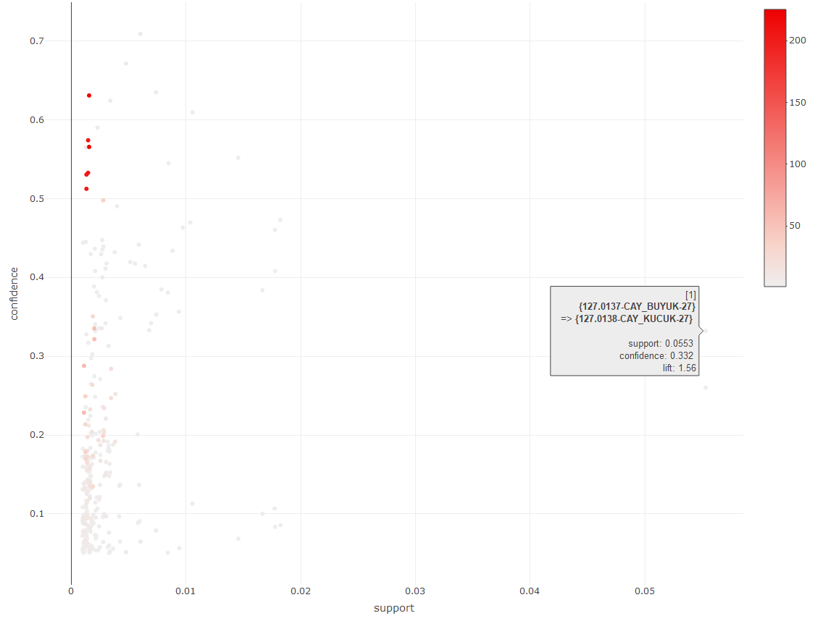

Figure 5.5 Rules of product scatter plot

Figure 5.5 shows the first rule line of Figure 5.4 has the highest support rate in all the rules. Figure 5.5 also offers us a comparison of confidence, support and lift values of all rules. Accordingly, the confidence is specified in the y-axis, the support is in the x-axis, and in the end lift value is indicated by the color (darker red with higher lift value).

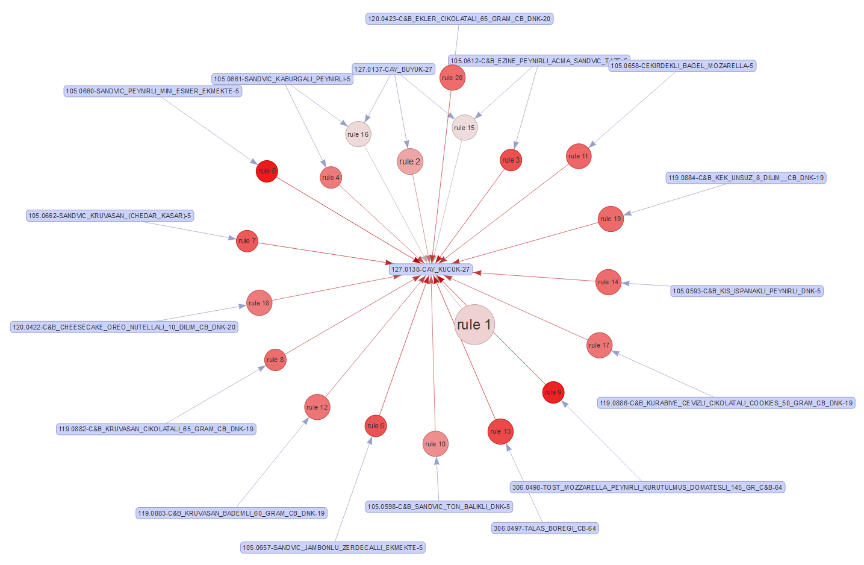

Figure 5.6 Rules of ÇAY KÜÇÜK

Figure 5.6 shows the rules around the “ÇAY KÜÇÜK” product. Here “ÇAY KÜÇÜK” is held on the right side of the rule. The aim is to make a list of products that can be offered with “ÇAY KÜÇÜK”. Arrows in the graph indicate the direction of the sales, the size of the circles indicate the size of the support value and the colors indicate the lift value.

|  |
| --- |
| **LHS RHS support confidence lift count** [1] {} => {127.0138-CAY_KUCUK-27} 0.2126 0.21 1.00 62387 [2] {127.0137-CAY_BUYUK-27} => {127.0138-CAY_KUCUK-27} 0.0553 0.33 1.56 16225 [3] {105.0612-C&B_EZINE_PEYNIRLI_ACMA_SANDVIC_TAZE-5} => {127.0138-CAY_KUCUK-27} 0.0182 0.47 2.23 5352 [4] {105.0661-SANDVIC_KABURGALI_PEYNIRLI-5} => {127.0138-CAY_KUCUK-27} 0.0178 0.41 1.92 5213 [5] {105.0660-SANDVIC_PEYNIRLI_MINI_ESMER_EKMEKTE-5} => {127.0138-CAY_KUCUK-27} 0.0146 0.55 2.60 4275 [6] {105.0657-SANDVIC_JAMBONLU_ZERDECALLI_EKMEKTE-5} => {127.0138-CAY_KUCUK-27} 0.0104 0.47 2.21 3053 [7] {105.0662-SANDVIC_KRUVASAN_(CHEDAR_KASAR)-5} => {127.0138-CAY_KUCUK-27} 0.0098 0.46 2.18 2863 [8] {119.0882-C&B_KRUVASAN_CIKOLATALI_65_GRAM_CB_DNK-19} => {127.0138-CAY_KUCUK-27} 0.0089 0.43 2.04 2598 [9] {306.0498-TOST_MOZZARELLA_PEYNIRLI_KURUTULMUS_DOMATESLI} => {127.0138-CAY_KUCUK-27} 0.0085 0.55 2.56 2490 [10] {105.0598-C&B_SANDVIC_TON_BALIKLI_DNK-5} => {127.0138-CAY_KUCUK-27} 0.0079 0.38 1.81 2309 [11] {105.0658-CEKIRDEKLI_BAGEL_MOZARELLA-5} => {127.0138-CAY_KUCUK-27} 0.0059 0.44 2.08 1734 [12] {119.0883-C&B_KRUVASAN_BADEMLI_60_GRAM_CB_DNK-19} => {127.0138-CAY_KUCUK-27} 0.0052 0.42 1.97 1516 [13] {306.0497-TALAS_BOREGI_CB-64} => {127.0138-CAY_KUCUK-27} 0.0040 0.49 2.31 1179 [14] {105.0593-C&B_KIS_ISPANAKLI_PEYNIRLI_DNK-5} => {127.0138-CAY_KUCUK-27} 0.0038 0.43 2.03 1109 [15] {105.0612-C&B_EZINE_PEYNIRLI_ACMA_SANDVIC_TAZE-5,   127.0137-CAY_BUYUK-27} => {127.0138-CAY_KUCUK-27} 0.0033 0.19 0.88 970 [16] {105.0661-SANDVIC_KABURGALI_PEYNIRLI-5,   127.0137-CAY_BUYUK-27} => {127.0138-CAY_KUCUK-27} 0.0032 0.19 0.90 938 [17] {119.0886-C&B_KURABIYE_CEVIZLI_CIKOLATALI_COOKIES-19} => {127.0138-CAY_KUCUK-27} 0.0031 0.42 1.97 909 [18] {120.0422-C&B_CHEESECAKE_OREO_NUTELLALI_10_DILIM-20} => {127.0138-CAY_KUCUK-27} 0.0030 0.41 1.93 875 [19] {119.0884-C&B_KEK_UNSUZ_8_DILIM__CB_DNK-19} => {127.0138-CAY_KUCUK-27} 0.0028 0.44 2.07 829 [20] {120.0423-C&B_EKLER_CIKOLATALI_65_GRAM_CB_DNK-20} => {127.0138-CAY_KUCUK-27} 0.0027 0.44 2.05 805 |

Figure 5.7 Rules of ÇAY KÜÇÜK list

Compared to Figure 5.6 and Figure 5.7, one of the highest confidence value appears to be “SANDVIC_PEYNIRLI_MINI_ESMER_EKMEKTE”. Accordingly, people who buy “SANDVIC_PEYNIRLI_MINI_ESMER_EKMEKTE” can be offered “ÇAY KÜÇÜK” with a confidence of 55%. The lift value between these products quite highly considers in twenty products.

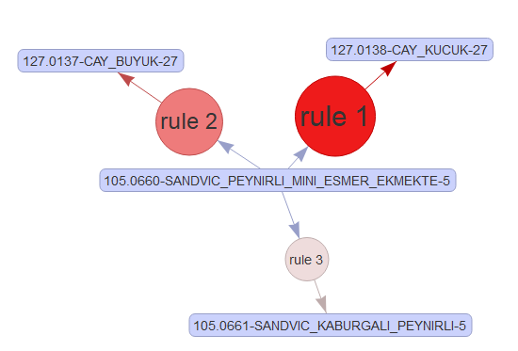

Figure 5.8 Rules of “SANDVIC_PEYNIRLI_MINI_ESMER_EKMEKTE”

Figure 5.8 shows some of the RHS rules that occur when we put the “SANDVIC_PEYNIRLI_MINI_ESMER_EKMEKTE” on the LHS. Customers who buy “SANDVIC_PEYNIRLI_MINI_ESMER_EKMEKTE” according to Figure 5.8 can be offered "ÇAY KÜÇÜK", "ÇAY BÜYÜK" and "SANDVİÇ KABURGALI PEYNIRLI". The two products("ÇAY KÜÇÜK", "ÇAY BÜYÜK"), with large circles, indicate the higher support value, the color density of the red circle indicate the higher lift value.

Similarly, a relationship is found between “TOST_MOZZARELLA” and “ÇAY KÜÇÜK”. When the two rule values are examined, both rules have the same confidence values. In addition, the lift values are very close to each other. However, there is a difference between the support values. While the support value of the 5th rule is 0.0146, the support value of the 9th rule is 0.0085. In this context, the fifth order seems more valuable. Finding and ordering interesting rules is a very broad concept.

## Apriori Algorithm on Categories

As mentioned before, the analysis is carried out on two separate dimensions of the data. Examines the association rules through sales categories in this section of the analysis.

|  |
| --- |
| [1] "981780793310\nSiseli Içecekler"  [2] "981780793310\nSandviçler"   [3] "105171241300\nSandviçler"  [4] "105598683310\nUnlu Mamüller"   [5] "105171241300\nBira Grubu"  [6] "105171241300\nBira Grubu"   [7] "105171241300\nBira Grubu"  [8] "105598683310\nUnlu Mamüller"   [9] "144171241300\nBira Grubu"  [10] "144171241300\nSandviçler" |

Figure 5.9 Transaction of categories

Figure 5.9 shows some examples of sales categories transactions.

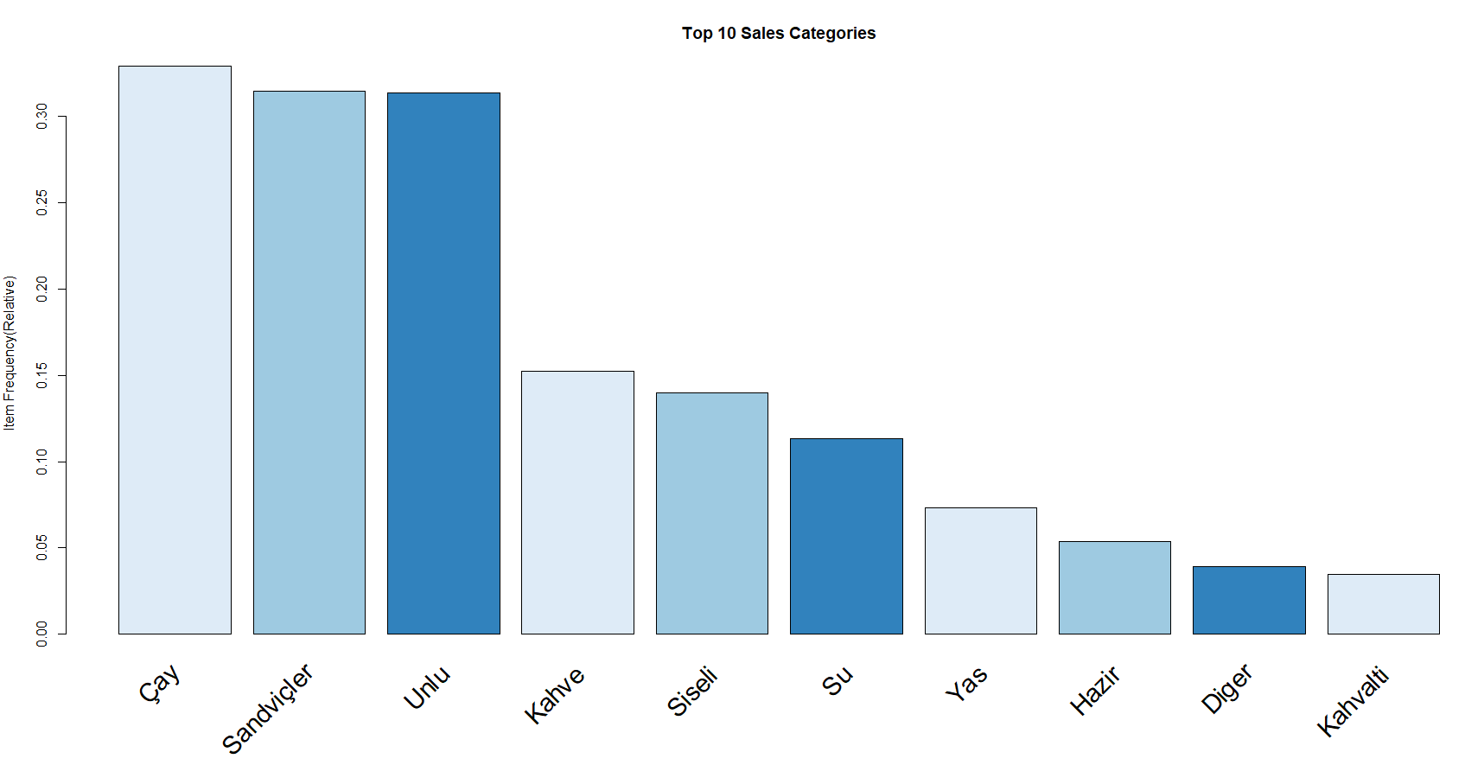

Figure 5.10 Top ten sales categories

There are 30 sales categories in our dataset. And you can see the top ten sales categories in Figure 5.10. “Çay”, “Sandviçler” and “Unlu”, these three categories are strictly separated than the other categories depends on the amount.

|  |
| --- |
| **LHS RHS support confidence lift count** [1] {Çay} => {Sandviçler} 0.1412 0.429 1.4 41456 [2] {Sandviçler} => {Çay} 0.1412 0.449 1.4 41456 [3] {Kahve} => {Unlu} 0.0505 0.331 1.1 14826 [4] {Unlu} => {Kahve} 0.0505 0.161 1.1 14826 [5] {Siseli} => {Kahve} 0.0295 0.211 1.4 8658 [6] {Kahve} => {Siseli} 0.0295 0.194 1.4 8658 [7] {Yas} => {Çay} 0.0255 0.349 1.1 7488 [8] {Çay} => {Yas} 0.0255 0.078 1.1 7488 [9] {Hazir} => {Çay} 0.0197 0.368 1.1 5781 [10] {Çay} => {Hazir} 0.0197 0.060 1.1 5781 [11] {Diger} => {Unlu} 0.0145 0.368 1.2 4258 [12] {Hediyelik} => {Çay} 0.0109 0.531 1.6 3195 [13] {Pide} => {Siseli} 0.0092 0.465 3.3 2696 [14] {Siseli} => {Pide} 0.0092 0.066 3.3 2696 [15] {Bira} => {Su} 0.0069 0.393 3.5 2019 [16] {Su} => {Bira} 0.0069 0.061 3.5 2019 [17] {Kahvalti} => {Hazir} 0.0065 0.189 3.5 1918 [18] {Hazir} => {Kahvalti} 0.0065 0.122 3.5 1918 [19] {Kahvalti} => {Siseli} 0.0055 0.160 1.1 1628 [20] {Meyveli} => {Çay} 0.0049 0.508 1.5 1441 [21] {Pide} => {Kahve} 0.0041 0.208 1.4 1206 [22] {Çikolatalar} => {Çay} 0.0029 0.544 1.7 856 [23] {Pizza} => {Diger} 0.0027 0.154 3.9 781 [24] {Diger} => {Pizza} 0.0027 0.067 3.9 781 [25] {Büfeler} => {Kahvalti} 0.0026 0.389 11.2 759 [26] {Kahvalti} => {Büfeler} 0.0026 0.075 11.2 759 [27] {Açik} => {Siseli} 0.0024 0.198 1.4 709 [28] {Makarna} => {Siseli} 0.0021 0.305 2.2 604 [29] {Büfeler} => {Hazir} 0.0019 0.287 5.4 560 [30] {Paketli} => {Çay} 0.0016 0.424 1.3 469 [31] {Meyveli} => {Yas} 0.0014 0.148 2.0 421 [32] {Açik} => {Kahvalti} 0.0013 0.108 3.1 388 [33] {Pide} => {Diger} 0.0011 0.058 1.5 334 [34] {Salatalar} => {Diger} 0.0011 0.143 3.6 328 [35] {Açik} => {Hazir} 0.0011 0.088 1.6 317 |

Figure 5.11 Association rules of categories

Figure 5.11 shows a list of association rules for categories. As before, rules are listed according to support values. So Figure 5.11 shows the rules with sorted decreasing by support valued rule. However, as before, the minimum support value was set as 0.05 and the minimum confidence value was set as 0.05. Finally, the rules were checked also for statistical significance and redundant rules were excluded as we did the previous stage. With these parameters, the algorithm created 35 rules.

According to the rules in the first row, who buy “ Çay” it is 42% likely to buy a “Sandviçler”. This rate is 44% when the categories switch. And this rule corresponds to 14% of the total rules. On the third line people who bought “Kahve” also buy “Unlu” with the %33 probability rate. Although the value of the support is low, the confidence value between "Hediyelik" and "Çay" is 53%. It shows that for every two customers of who buys “Hediyelik”, one of them prone take to “Çay”. There is also a similar relationship between "Meyveli" and "Çay".

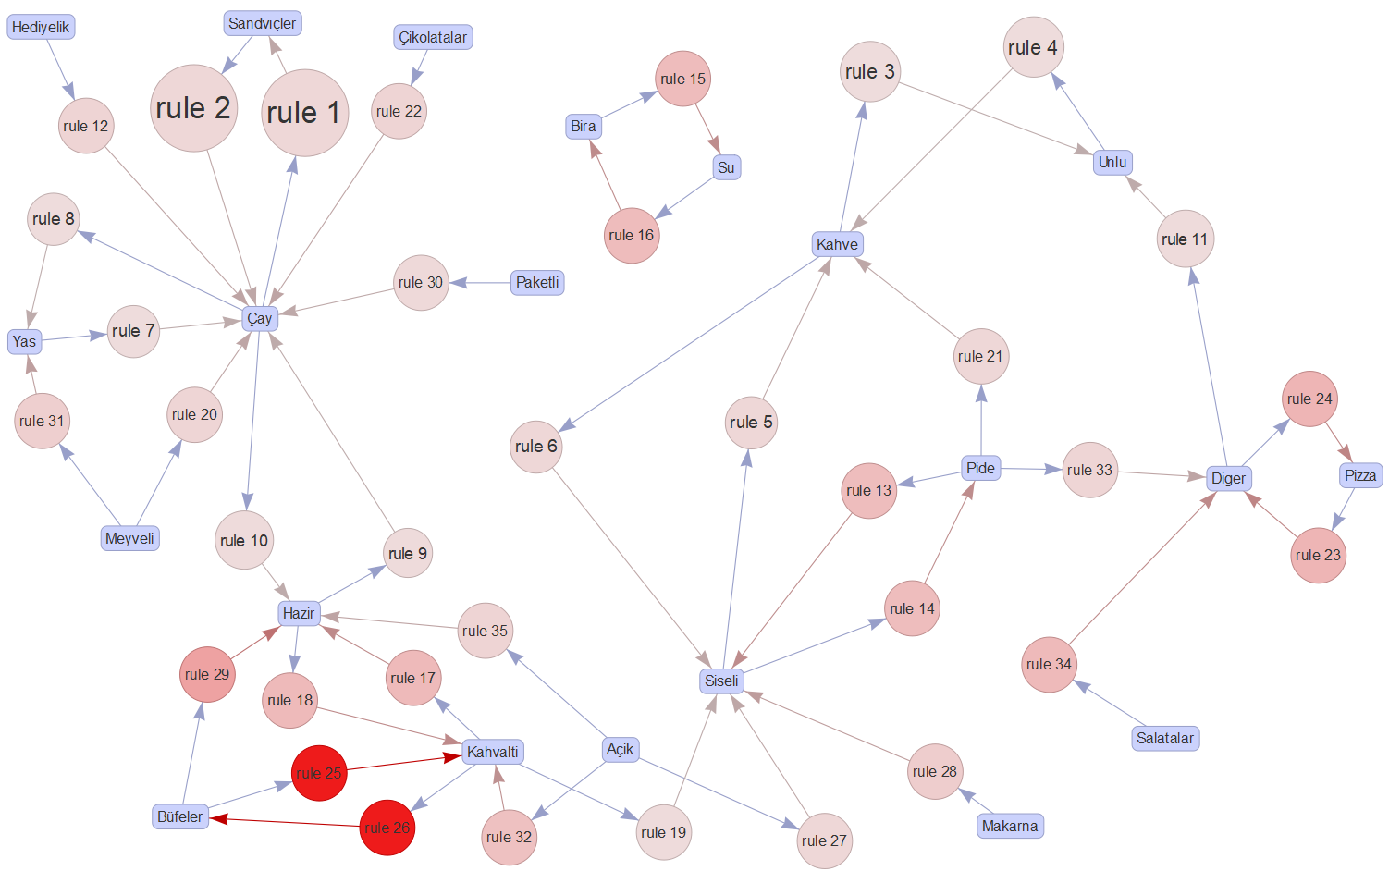

Figure 5.12 Rules of categories

Figure 5.12 shows the relationships between the 35 rules created. When Figure 5.12 is examined, it can be seen that there are quite a few rules around the “Çay” group. Rule 1 and rule 2 support values are the highest values. The highest lift value belongs to the rules between "Büfeler" and "Kahvalti" groups. It is important to note that “Bira” and “Su” groups are the only rules between each other. The “Kahvalti” group has established rules only with the group “Hazir” and “Büfeler”. Opposite that “Şişeli” has formed rules with many groups. As you can imagine, the “Şişeli” contains bottled drinks. Therefore, it is seen in many categories. “Kahve” establishes relations with only “Şişeli” and “Unlu” groups. Especially the rules established with the “Unlu” group have high support value.

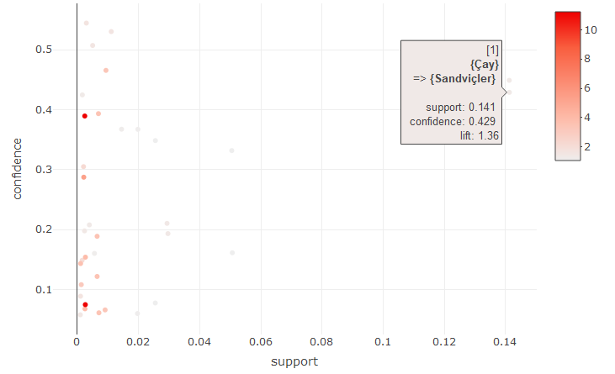

Figure 5.13 Rules of categories scatter plot

You can see all the rules in Figure 5.13. The high support value of the “Çay” and “Sandviçler” group can be clearly seen in Figure 5.13. Figure 5.14 shows what can be offered in the "Sandviçler" category when "Çay" is sold. Accordingly, "SANDVİÇ_PEYNIRLI MINI ESMER EKMEKTE", "EZINE PEYNIRLI AÇMA SANDVIC TAZE" and "SANDVİÇ KABURGALI PEYNIRLI" are the most recommended products.

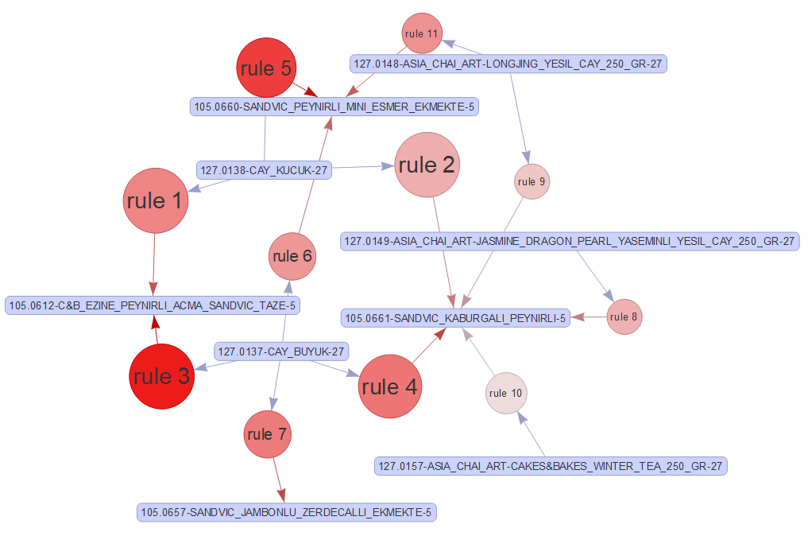

Figure 5.14 Çay-Sandviç Rules

Figure 5.15 shows the relationship between "Sandviçler" and "Çay" in a reverse manner. In this case, except for the products in the first case, some products are coming. At this point, we should realize that the reverse of the rules is not the same.

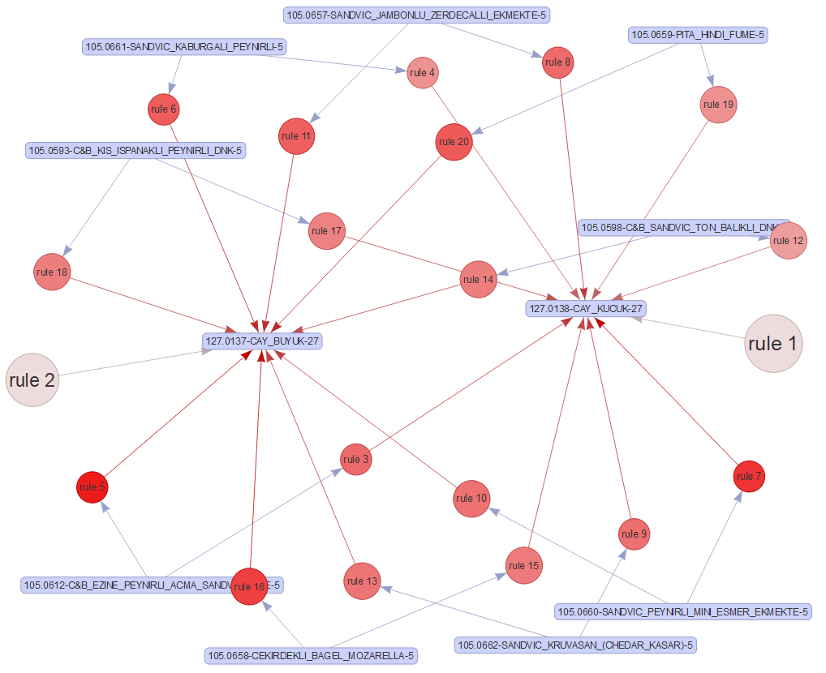

Figure 5.15 Sandviçler-Çay Rules

When we change the categories in the rules we observe the difference in customer behaviors. According to Figure 5.15, there are nine products in “Sanviçler” categories create the rules in “Çay” category. Most of that rules have very high lift values cause we understand that the red color density in this figure. Both “rule 1” and “rule 2 in Figure 5.15, show only rules that have “Çay” on the LHS of the rules.

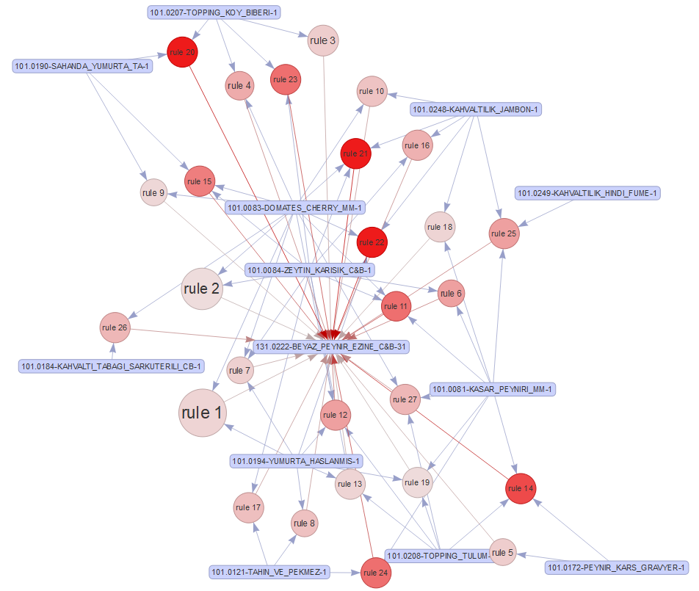

Figure 5.16 Kahvalti Büfe Rules

The highest lift value belongs to “Büfeler” and “Kahvalti” groups. The reddest dots in the graph indicate these rules. For example, there are valuable rules for a high lift between "TOPPING KOY BIBERI" and "BEYAZ PEYNIR EZINE" or "KAHVATILIK JAMBON" and "BEYAZ PEYNIR EZINE". In general terms, "BEYAZ PEYNIR EZINE" in the "Büfeler" category has formed very high-value rules with the products in the "Kahvalti" category. "BEYAZ PEYNIR EZINE" alone is the product that brings both categories closer together.

As we mentioned before “Kahve” and “Unlu” creates rules which have got high support values. When we examine Figure 5.17, we see that the products belonging to the "Kahve" category create the rules with "KRUVASAN SADE" and "SİMİT PASTANE" belonging to the "Unlu" category. Unlike the main group of coffee, “TÜRK KAHVESİ” has formed a separate rule with “SARMA PEYNIRLI AÇMA”.

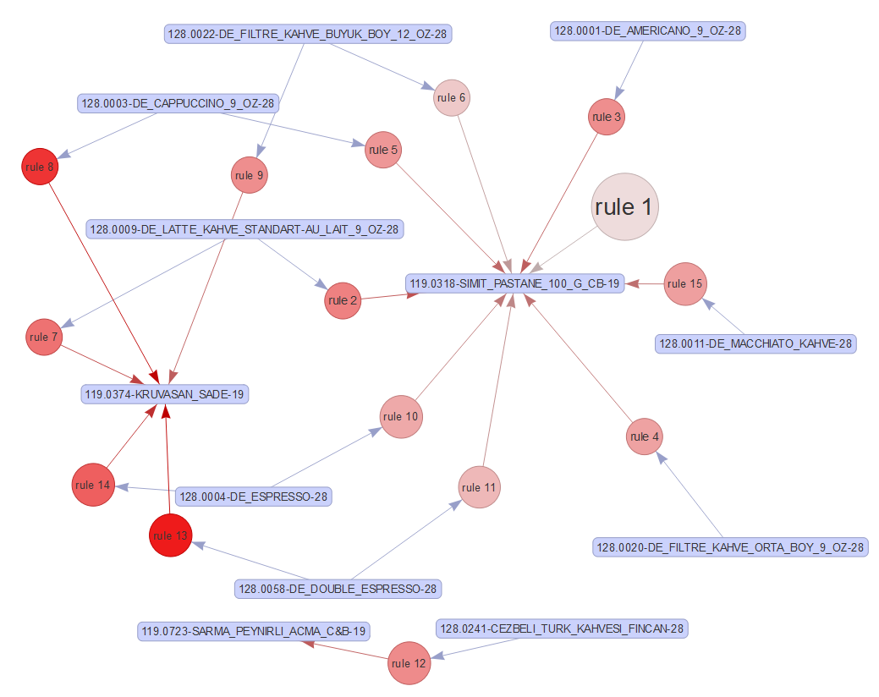

Figure 5.17 Kahve Unlu Rules

## Similarity on Categories

The product placement is also important in the food sector as in the retail sector. This situation can be addressed in many ways for considering a cafe. In the design of the menu or in the design of the showcases where the products are located, the product layout must be done correctly. The layout is an important factor affecting the interior design of the cafe. The operation is carried out accordingly. The fact that customers reach the products easily and correctly in a grouped manner also affects profitability.

Therefore, the similarities between the categories in this part of the analysis are examined. Similarity analysis was done by using Jaccard similarity formula. Hierarchical clustering was performed over the values found. Figure 5.12 shows the categories of dendrograms.

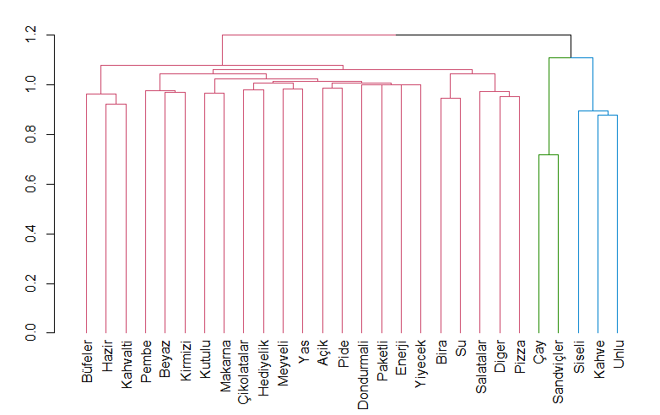

Figure 5.18 Dendrogram for categories

Parallel to the results of the association rules analysis conducted on the category, "Çay" and "Sandviçler" are included in the same cluster. Similarly, "Kahve" and "Unlu" are also in the same cluster. This cluster forms a separate cluster with the "Şişeli" category at a higher level. These five categories should be evaluated separately as they constitute a large part of the turnover. These categories are divided into top-level branches from other categories.

## Analysis of the Excluded Data

As the purpose of market basket analysis is to find the product patterns sold together, the products sold alone are excluded from the analysis. Although this is a correct approach in terms of purpose, it is necessary to examine the products sold alone in the analysis. The inclusion of products sold alone can be useful in identifying potentials such as missed sales opportunities. In this part of the study, the data sold alone is analyzed.

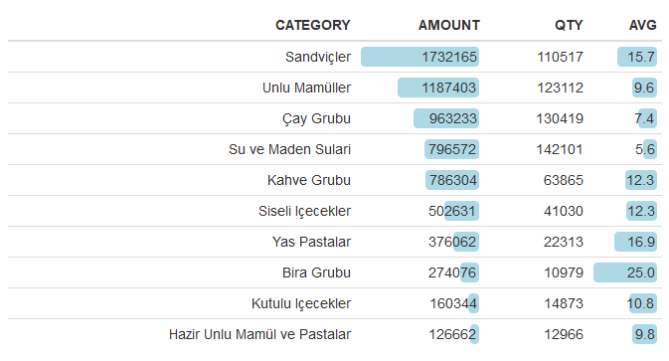

Table 5.1 Sales categories for sold alone

Table 5.1 shows the top ten sold alone products with the highest sales amount. In total, 728.218 of 1.341.030 row data was excluded from the analysis. This part of dataset becomes, the number of row and piece in the row both of this is equal to one. So this dataset refers to the sale of a single product in a single line. This type of dataset cannot be expected to form association rules. However, this dataset should be examined if it does not make the correct recommendations. If the recommendations were made by using the product stacks in the analysis, how much return could be provided?

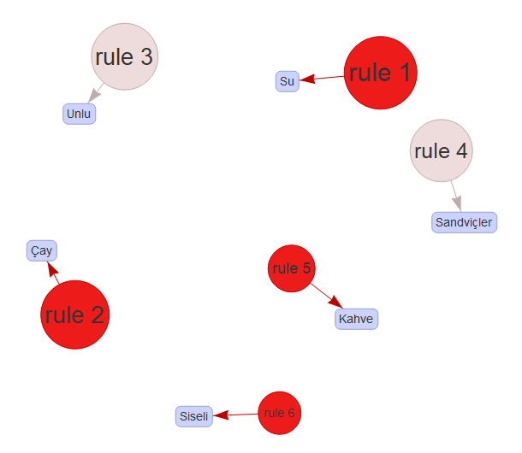

Figure 5.19 Rules for sold alone categories

In Table 5.2 shows us categories which are made the rules with the highest confidence value to the first six categories in Table 5.1. When the bundles in Table 5.2 are examined, it is seen that the average confidence value is 27%. Therefore, if the correct recommendations were made for the correct category, a turnover of 27% of the total sales could be made.

|  |  |  |  |
| --- | --- | --- | --- |
| **LHS** |  | **RHS** | **Confidence** |
| Sandviçler | => | Çay Grubu | 45% |
| Unlu Mamüller | => | Kahve Grubu | 16% |
| Çay Grubu | => | Sandviçler | 43% |
| Su ve Maden Sulari | => | Bira Grubu | 6% |
| Kahve Grubu | => | Unlu Mamüller | 33% |
| Siseli Içecekler | => | Kahve Grubu | 21% |

Table 5.2 Rules of sales categories with the highest confidence

The rates in this section give us the highest potential. This is exactly what happens if everything goes well and the estimates hold. For the correct interpretation of the analysis, it is necessary to underline this situation.

# DISCUSSION

The combined product patterns indicate more than just the recommendation for the sale of new products. In a cafe operation, there are other results that can be extracted using this data. Cafe operation shows a similarity with the retail sector. The settlement is very important in both sectors.

In the settlement can be handled with differences in itself. These data can be used in terms of the placement of the store or this data can be used in terms of product placement. Store placement is one of the most important factors that directly affect profitability. Of course, it is not possible to decide on a cafe design only by looking at the product associations. However, the associations provide important clues to the decision maker.

Another important aspect of the layout is the menu design. One of the conclusions drawn from the analysis of association rules can be used in the menu design. Products that are sold together can be placed side by side on the menu. Or categorization using product associations

In this study, relationships between products and product sales categories were tried to be found by using the analysis methods. The study was carried out in accordance with the CRISP-DM methodology. Firstly, the data mining phase was completed. The data obtained from this section consist of two dimensions. One of them is product and the other one is to issue the rules of association on the basis of category. In this article, the R programming language and the arules package were analyzed using the Apriori algorithm.

As a result of this analysis, important information and designs have been obtained about the products and categories that have a tendency to purchase together. A similarity analysis was performed on the category matrix obtained in the next stage. The distances between the product categories calculated with the Jaccard formula contain important results for store layout and menu design.

In the last stage of the analysis, potential outcomes of the recommendations that can be made by using association rules over the data not included in the analysis are discussed. The sold alone products were excluded in order to not affect the sales patterns together in the first part of the analysis but were reevaluated at the end of the study for potential cross-selling opportunities.

The lack of customer information within the data set is one of the factors that hamper the development of the study. Obtaining different information about the customer (age, gender, nationality ...) can lead to more rich recommendations. Especially, considering the diversity of the customers at the airport, this information is essential for the differentiation of the recommendations.

# CONCLUSION

In this study, the associations between the products and the categories were investigated through the sales data of the three cafes at the airports. The purpose of the analysis is to uncover the rules of association over two dimensions of the ten-month sales data and to provide patterns for cross-selling to operations teams.

For this purpose, we mapped the associations between the products. These results are listed in the recommendations for cross-selling. The sales staff should be trained on these suggestions and they should make suggestions during the sale to increase sales. Using this information, it is proposed to place visual ads on the screens at the point of sale, indicating the associated production of the product being sold.

As a result of the analysis, it was determined that the “Çay” and “Sandviç” group were the most sold categories. Accordingly, it is recommended that the “Çay” and “Sandviç” categories should be positioned in a café to make the customers more circulating in order to increase the sales of products with low sales values.

In the f&b sector, cost of goods sold(COGS) is a very important value to examine the profit. Cost of goods sold is the only cost of components to the production of the goods. When the cost of good sold deducted from the sales price you reach the gross profit for the products. In the future, if we can add the cost of the goods attribute to the dataset, we can evaluate the products over their profitability rather than their amount.

In the analysis of goods sold alone, confidence values were calculated for the success of the proposals. This value is meaningful when all possible possibilities occur. However, in practice, it may not be possible to reach this percentage when the suggestions are already made on the degree of saturation. This situation necessitates a criterion for measuring the success of the recommendations to the customers. A sector-based conversion rate value can be studied to measure this in the future.

# References

[1] M. Hahsler, *Mining Association Rules and Frequent Itemsets with R: mhahsler/arules*. 2018.

[2] M. Hahsler and S. Chelluboina, ‘Visualizing Association Rules: Introduction to the R-extension Package arulesViz’, p. 24.

[3] J. Han, J. Pei, and M. Kamber, *Data Mining: Concepts and Techniques*. Elsevier, 2011.

[4] P.-N. Tan, M. Steinbach, and V. Kumar, ‘Introduction to Data Mining’, p. 169.

[5] I. H. Witten, E. Frank, M. A. Hall, and C. J. Pal, *Data Mining: Practical Machine Learning Tools and Techniques*. Morgan Kaufmann, 2016.

[6] M. J. A. Berry and G. Linoff, *Data mining techniques: for marketing, sales, and customer relationship management*, 2nd ed. Indianapolis, Ind: Wiley Pub, 2004.

[7] M. A. Ulaş, E. Alpaydın, N. Sönmez, and A. Kalkan, ‘Veri Madenciliğinde Sepet Analizi Uygulamaları’, *Bilişim 2001*, 2001.

[8] D. Ay and İ. Çi̇L, ‘MİGROS TÜRK A.Ş.DE BİRLİKTELİK KURALLARININ YERLEŞİM DÜZENİ PLANLAMADA KULLANILMASI’, p. 16.

[9] I. Cil, ‘Consumption universes based supermarket layout through association rule mining and multidimensional scaling’, *Expert Syst. Appl.*, vol. 39, pp. 8611–8625, Aug. 2012.

[10] R. Agrawal, T. Imielinski, A. Swami, H. Road, and S. Jose, ‘Mining Association Rules between Sets of Items in Large Databases’, p. 10.

[11] R. Agrawal, R. Srikant, H. Road, and S. Jose, ‘Fast Algorithms for Mining Association Rules’, p. 13.

[12] G. Mariscal, ‘A Survey of Data Mining and knowledge discovery process Models and methodologies’.